American International University-Bangladesh (AIUB)
Faculty of Science and Technology
Department of Computer Science

Web Technologies
CSE 4101 / CSC3215
PROJECT REPORT

Project Title:
Event Management System - Organiser Portal

Semester: Spring 2025–2026
Submission Date: 05/18/2026
Section: M

Submitted To:
SULTANUL ARIFEEN HAMIM
lecturer, Faculty
Department Of Computer Science
American International University-Bangladesh

Group Information
Fill in all fields below. Each group member must sign before submission.

Group Number: 07

Project Title: Event Management System - Organiser Portal

Student Information:

Full Name: SUDIPTA SARKER UNNAYAN
Student ID: 22-47656-2
Program: Bachelor of Science in Computer Science & Engineering
Email: sudiptasarker2003@gmail.com

Signature: _____________________________

Declaration: We hereby declare that this project report is our original work. Any external resources or references used have been properly cited. We have not engaged in any form of academic dishonesty.

Marks Sheet
To be filled by the instructor only. Students must NOT write in this section.

Group No. |  | Section
Member 1 ID

CO3: Illustrate Multi-Tier Web Application for Targeted Society
Feature Implementation (0-3) |  |  | Feature Implementation (0-3) |  | Completeness (0-3)
Basic Web Security | UI (HTML/CSS) | Feature Completeness | DB | Auth (Session/cookie) | MVC
CO4: Coordinate with Group Members to Develop Multi-Tier Application
Technical Knowledge (0-3) |  |  | Collaborative Teamwork (0-3) |  |  | Communication/Promptness (0-3)
JS validation | PHP Validation | Ajax/JSON | Git Contribution |  |  | VIVA
Expected Outcome (0-2) |  | CO3 Total | CO4 Total |  |  | Project Total

Evaluated By: __________________________ Date: __________________

Course Teacher Signature: _______________________

Table of Contents

1. Group Information 2
2. Marks Sheet 3
3. Table of Contents 4
4. Chapter 1: Project Overview 9
4.1 Project Description 9
4.1 Technologies Used 10
4.3 System Architecture / MVC Diagram 11
4.4 Database Schema 12
5. Chapter 2: Git Contribution & Task Allocation 13
5.1 GitHub Repository Link 13
5.2 Git Contribution Screenshot 14
6. Chapter 3: Features, Source Code & Screenshots 16
7.1 16
7.2 17
7. Chapter 5: Conclusion & Future Work 18

Chapter 1: Project Overview

1.1 Project Description
The Event Management System is a full stack web application built using PHP (MVC architecture), MySQL, and vanilla JavaScript. The system is designed for three types of users: Event Organisers, Venue Managers, and Platform Administrators.

This report covers the Event Organiser Portal the role responsible for creating and managing events, selling tickets, handling attendees, and analysing event performance. The portal provides a complete self service dashboard where organisers can publish events, manage ticket tiers, send announcements, process refunds, and track real time check ins.

1.2 Technologies Used
List all technologies, frameworks, and tools used in this project.

Layer | Technology / Tool | Purpose
Frontend | HTML5, CSS3 (Custom) | UI & Responsive Layout
 | JavaScript (Vanilla) | Client-side validation, AJAX check-in
Backend | PHP 8 (MVC Pattern) | Server-side logic & routing
Database | MySQL | Data storage with prepared statements
Auth | PHP Sessions, CSRF Tokens | Authentication & form protection
Version Control | Git / GitHub | Collaboration & feature branching
Server | XAMPP / Apache | Local development environment

1.3 System Architecture / MVC Diagram
The application follows the Model View Controller (MVC) pattern. All requests are routed through index.php, which dispatches to the appropriate Controller. Controllers interact with Models (database layer) and load Views (HTML output). [ In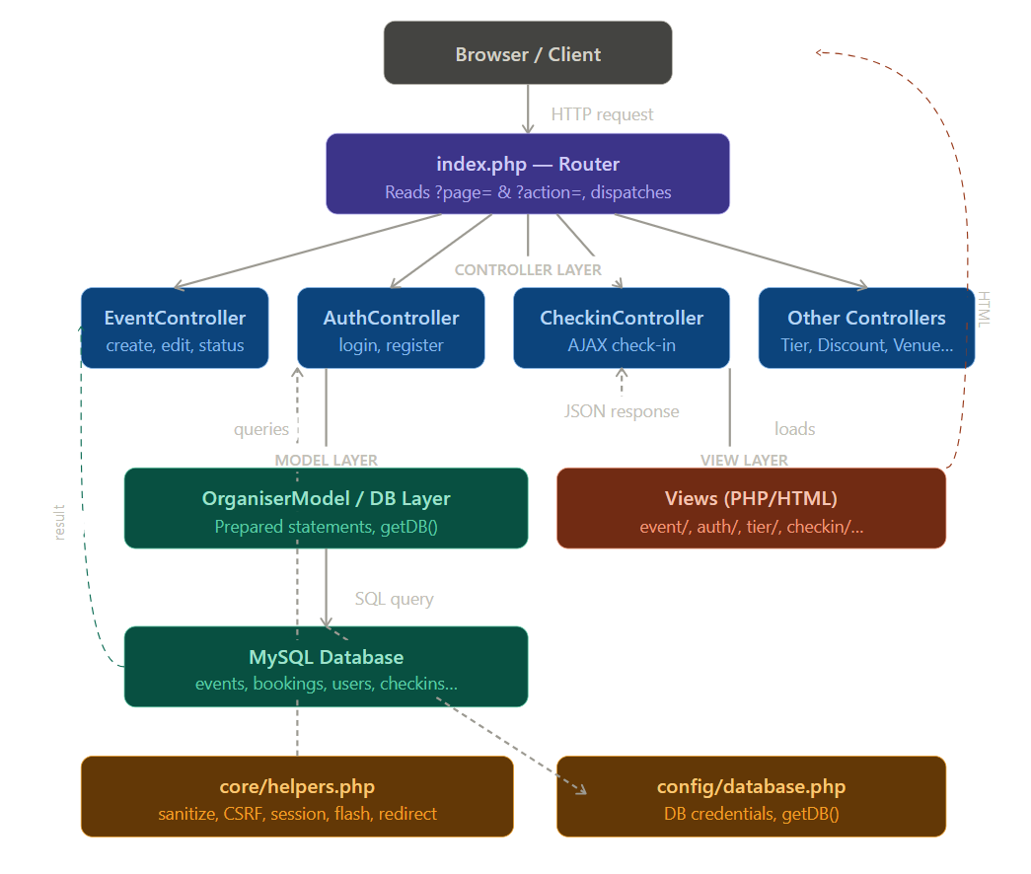

1.4 Database Schema
List your database tables and their key fields.
Table | Field | Type | Description
users | id | INT (PK) | Primary key
 | name, email | VARCHAR | User name and login email
 | password_hash | VARCHAR | bcrypt hashed password
 | role | ENUM | attendee / organiser / venue_manager / admin
 | is_active | TINYINT | Account active/inactive flag
organiser_profiles | id | INT (PK) | Primary key
 | user_id | INT (FK) | Links to users table
 | org_name | VARCHAR(150) | Organisation name
 | org_logo_path | VARCHAR | Uploaded logo file path
 | status | ENUM | pending / approved / suspended
events | id | INT (PK) | Primary key
 | organiser_id | INT (FK) | Links to users (organiser)
 | venue_id | INT (FK) | Optional — links to venues
 | category_id | INT (FK) | Links to categories
 | title | VARCHAR(200) | Event title
 | event_datetime | DATETIME | Event start date and time
 | end_datetime | DATETIME | Event end date and time
 | banner_image_path | VARCHAR | Uploaded banner image path
 | status | ENUM | draft / published / cancelled / completed
ticket_tiers | id | INT (PK) | Primary key
 | event_id | INT (FK) | Links to events
 | name | VARCHAR(100) | e.g. VIP, General, Early Bird
 | price | DECIMAL(10,2) | Ticket price in BDT
 | total_seats | INT | Total seat capacity
 | sales_start / sales_end | DATETIME | Ticket sale window
bookings | id | INT (PK) | Primary key
 | attendee_id | INT (FK) | Links to users (attendee)
 | event_id / tier_id | INT (FK) | Links to events and ticket_tiers
 | ticket_code | VARCHAR(50) | Unique ticket identifier
 | total_price | DECIMAL(10,2) | Final amount paid
 | checked_in | TINYINT | Check-in status 0/1
 | checked_in_at | DATETIME | Timestamp of check-in
 | status | ENUM | active / cancelled / refunded
discount_codes | id | INT (PK) | Primary key
 | event_id | INT (FK) | Links to events
 | code | VARCHAR(50) | Promo code e.g. SAVE20
 | discount_pct | DECIMAL(5,2) | Discount percentage
 | max_uses / uses_count | INT | Usage limit and current count
 | valid_until | DATETIME | Expiry date
announcements | id | INT (PK) | Primary key
 | event_id | INT (FK) | Links to events
 | title | VARCHAR(200) | Announcement subject
 | body | TEXT | Full message body
 | sent_at | DATETIME | Timestamp of announcement
event_reviews | id | INT (PK) | Primary key
 | event_id / booking_id | INT (FK) | Links to events and bookings
 | rating | TINYINT | Score 1-5 with CHECK constraint
 | review_text | TEXT | Attendee review content
 | organiser_reply | TEXT | Organiser reply to review
refund_requests | id | INT (PK) | Primary key
 | booking_id | INT (FK) | Links to bookings
 | reason | TEXT | Refund reason from attendee
 | status | ENUM | pending / approved / rejected
 | organiser_note | TEXT | Organiser decision note
venues | id | INT (PK) | Primary key
 | manager_id | INT (FK) | Links to users (venue manager)
 | name, city | VARCHAR | Venue name and location
 | capacity | INT | Maximum guest capacity
 | facilities | JSON | List of available facilities
categories | id | INT (PK) | Primary key
 | name | VARCHAR(100) | e.g. Music, Technology, Sports

Chapter 2: Git Contribution & Task Allocation

2.1 GitHub Repository Link
Repository URL: _https://github.com/DeipToha/event_system______________________________________________

2.2 Git Contribution Screenshot
Insert a screenshot of your GitHub contribution graph / commit history here.
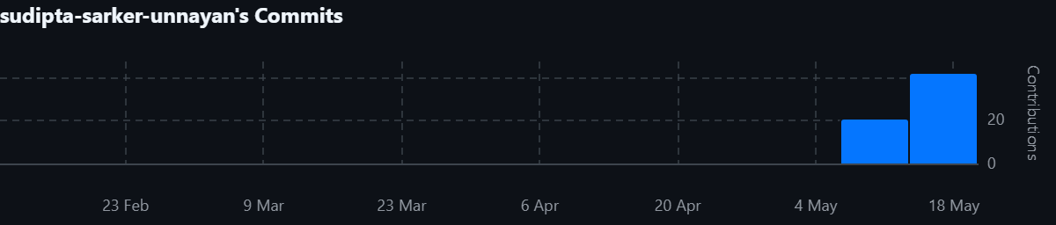

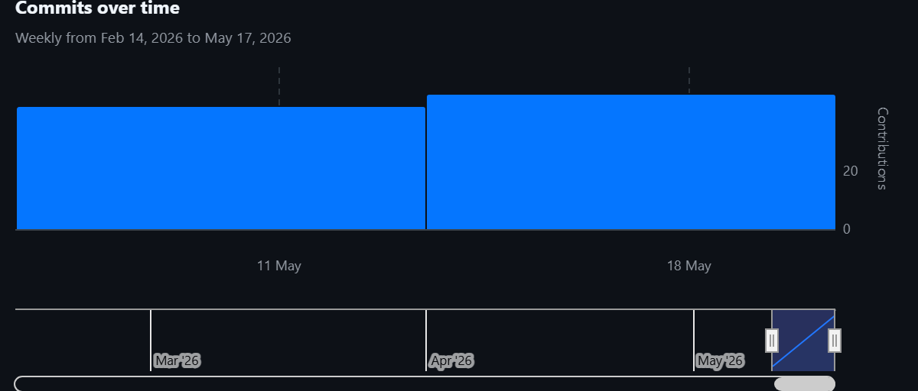

Feature Branch Name:
Organiser-Analytics
Organiser-Booking
Organiser-Check-review
Organiser-Checkin
Organiser-Dashboard
Organiser-Discount
Organiser-Event
Organiser-Profile
Organiser-Refund
Organiser-Send-Announcement
Organiser-Ticket-Control
Organiser-Vanue

Chapter 3: Features, Source Code & Screenshots
The Organiser Portal implements 16+ features. Key features are documented below with source code and screenshots.
Duplicate the feature section (Feature 1 block) as many times as needed — one block per feature.

Feature: Organiser Registration & Login (Authentication)
The Authentication feature allows a new event organiser to register an account by providing personal details and organisation information, including an optional logo upload. After registration, the account must be approved by the platform administrator before the organiser can log in. On login, the system validates credentials, checks account status (approved/active), and creates a secure PHP session. A logout action destroys the session. CSRF token verification and bcrypt password hashing are used throughout.

Description
The Authentication feature allows a new event organiser to register an account by providing personal details and organisation information, including an optional logo upload. After registration, the account must be approved by the platform administrator before the organiser can log in. On login, the system validates credentials, checks account status (approved/active), and creates a secure PHP session. A logout action destroys the session. CSRF token verification and bcrypt password hashing are used throughout.

Relevant Source Code
File: /organiser/controllers/AuthController.php
public function login() {
if (isset($_SESSION['user_id'])) redirect('index.php?page=dashboard');

$error = null;
if (isPost()) {
$email = trim($_POST['email'] ?? '');
$password = $_POST['password'] ?? '';

$user = UserModel::findByEmail($email);
if ($user && $user['role'] === 'organiser' && password_verify($password, $user['password_hash'])) {
$profile = OrganiserModel::getProfileByUserId($user['id']);
if (!$profile || $profile['status'] !== 'approved') {
$error = 'Your organiser account is pending admin approval.';
} elseif (!$user['is_active']) {
$error = 'Your account has been suspended.';
} else {
$_SESSION['user_id'] = $user['id'];
$_SESSION['role'] = $user['role'];
$_SESSION['name'] = $user['name'];
$_SESSION['org_name'] = $profile['org_name'];
$_SESSION['profile_id']= $profile['id'];
redirect('index.php?page=dashboard');
}
} else {
$error = 'Invalid email or password.';
}
}
require BASE_PATH . 'views\auth\login.php';
}

public function register() {
if (isset($_SESSION['user_id'])) redirect('index.php?page=dashboard');

$error = null;
$success = null;

if (isPost()) {
$name = sanitize($_POST['name'] ?? '');
$email = sanitize($_POST['email'] ?? '');
$phone = sanitize($_POST['phone'] ?? '');
$password = $_POST['password'] ?? '';
$org_name = sanitize($_POST['org_name'] ?? '');
$org_desc = sanitize($_POST['org_description'] ?? '');
$website = sanitize($_POST['website'] ?? '');

if (!$name || !$email || !$password || !$org_name) {
$error = 'Please fill all required fields.';
} elseif (strlen($password) < 6) {
$error = 'Password must be at least 6 characters.';
} elseif (UserModel::findByEmail($email)) {
$error = 'Email already registered.';
} else {
$logo_path = null;
if (!empty($_FILES['org_logo']['name'])) {
$logo_path = uploadFile($_FILES['org_logo'], BASE_PATH . 'public/uploads/');
}

$hash = password_hash($password, PASSWORD_BCRYPT);
$userId = UserModel::create($name, $email, $hash, $phone, 'organiser');
OrganiserModel::create($userId, $org_name, $org_desc, $logo_path, $website);
$success = 'Registration successful! Please wait for admin approval before logging in.';
}
}
require BASE_PATH . 'views/organiser/auth/register.php';
}

Code Explanation
The login() method first checks if a session already exists to avoid re-login. It validates that both email and password are provided and that the email format is valid using the helper isValidEmail(). It then calls UserModel::findByEmail() to retrieve the user record and uses PHP's built-in password_verify() to compare the submitted password against the stored bcrypt hash ensuring passwords are never stored in plain text. The organiser's profile is checked for admin approval status. suspended or unapproved accounts are blocked with a descriptive error. On success, user_id, role, and name are stored in the PHP session and the organiser is redirected to the dashboard. The register() method collects all required fields, validates them (including URL format for website), handles optional logo file upload using uploadFile(), hashes the password with PASSWORD_BCRYPT, and creates records in both the users and organiser_profiles tables. All POST forms use verifyCsrfToken() to protect against cross-site request forgery attacks.

Screenshot(s)
Insert relevant screenshots of the UI for this feature below. Right-click > Insert Picture, or drag and drop.
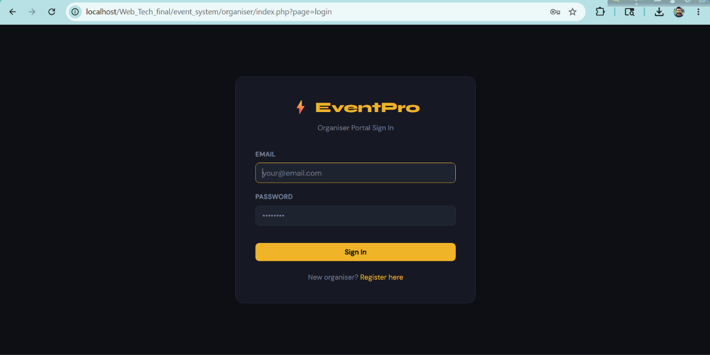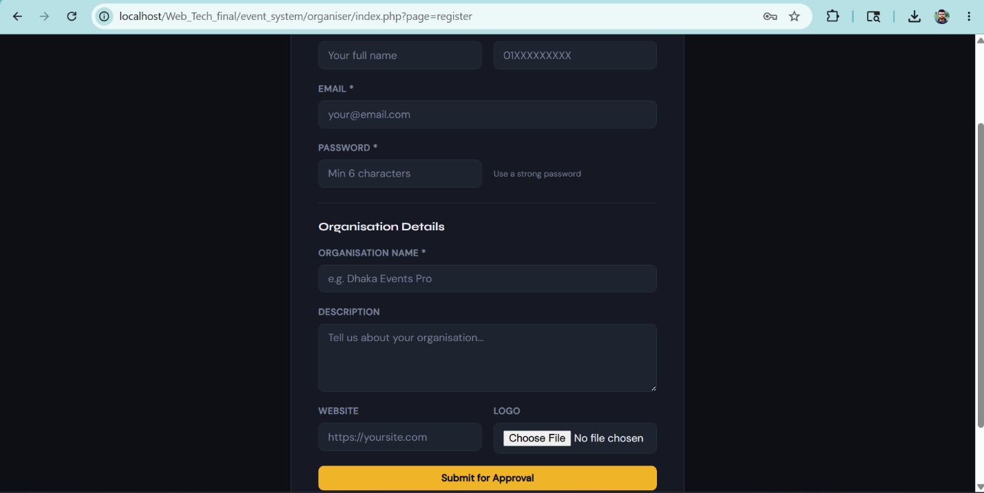[ Insert Screenshot Here — Right-click > Insert Picture ]

Feature: Event Management (Create, Edit, Publish, Cancel)
The Event Management feature allows an organiser to create, edit, change the status of, and manage their events. When creating an event, the organiser fills in the title, description, event start/end datetimes, category, and selects either a platform venue (from approved venue booking requests) or a custom venue name. An optional banner image can be uploaded. Events can be saved as Draft or Published. The organiser can later change the status to Published, Draft, or Cancelled. Cancelling an event automatically sends an announcement to all ticket holders.

Description
The Event Management feature allows an organiser to create, edit, change the status of, and manage their events. When creating an event, the organiser fills in the title, description, event start/end datetimes, category, and selects either a platform venue (from approved venue booking requests) or a custom venue name. An optional banner image can be uploaded. Events can be saved as Draft or Published. The organiser can later change the status to Published, Draft, or Cancelled. Cancelling an event automatically sends an announcement to all ticket holders.

Relevant Source Code
File: /organiser/controllers/EventController.php
{class EventController {

public function index() {
$db = getDB();
$org_id = $_SESSION['user_id'];
$stmt = $db->prepare("SELECT e.*, c.name as category_name FROM events e LEFT JOIN categories c ON e.category_id=c.id WHERE e.organiser_id=? ORDER BY e.created_at DESC");
$stmt->bind_param("i", $org_id);
$stmt->execute();
$events = $stmt->get_result()->fetch_all(MYSQLI_ASSOC);
$db->close();
require BASE_PATH . 'views/event/index.php';
}

public function create() {
$db = getDB();
$org_id = $_SESSION['user_id'];

$cats = $db->query("SELECT * FROM categories ORDER BY name")->fetch_all(MYSQLI_ASSOC);

$stmt = $db->prepare("SELECT vbr.*, v.name as venue_name, v.id as venue_real_id FROM venue_booking_requests vbr JOIN venues v ON vbr.venue_id=v.id WHERE vbr.organiser_id=? AND vbr.status='approved'");
$stmt->bind_param("i", $org_id);
$stmt->execute();
$approvedVenues = $stmt->get_result()->fetch_all(MYSQLI_ASSOC);

$error = null;
if (isPost()) {
$title = sanitize($_POST['title'] ?? '');
$description = sanitize($_POST['description'] ?? '');
$category_id = !empty($_POST['category_id']) ? (int)$_POST['category_id'] : null;
$event_dt = $_POST['event_datetime'] ?? '';
$end_dt = $_POST['end_datetime'] ?? '';
$status = in_array($_POST['status'] ?? '', ['draft','published']) ? $_POST['status'] : 'draft';
$venue_type = $_POST['venue_type'] ?? 'custom';
$venue_id = null;
$venue_override = null;

if ($venue_type === 'platform') {
$venue_id = !empty($_POST['venue_id']) ? (int)$_POST['venue_id'] : null;
} else {
$venue_override = sanitize($_POST['venue_name_override'] ?? '');
}

if (!$title || !$event_dt || !$end_dt) {
$error = 'Title and dates are required.';
} else {
$banner = null;
if (!empty($_FILES['banner_image']['name'])) {
$banner = uploadFile($_FILES['banner_image'], BASE_PATH . 'public/uploads/banners/');
}
$stmt2 = $db->prepare("INSERT INTO events (organiser_id, venue_id, category_id, title, description, venue_name_override, event_datetime, end_datetime, banner_image_path, status) VALUES (?,?,?,?,?,?,?,?,?,?)");
$stmt2->bind_param("iiisssssss", $org_id, $venue_id, $category_id, $title, $description, $venue_override, $event_dt, $end_dt, $banner, $status);
$stmt2->execute();
$new_id = $stmt2->insert_id;
$db->close();
setFlash('success', 'Event created successfully!');
redirect('index.php?page=tiers&action=manage&event_id=' . $new_id);
}
}
$db->close();
require BASE_PATH . 'views/event/create.php';
}

public function edit() {
$db = getDB();
$org_id = $_SESSION['user_id'];
$event_id = (int)($_GET['id'] ?? 0);

$stmt = $db->prepare("SELECT * FROM events WHERE id=? AND organiser_id=?");
$stmt->bind_param("ii", $event_id, $org_id);
$stmt->execute();
$event = $stmt->get_result()->fetch_assoc();
if (!$event) redirect('index.php?page=events');

$cats = $db->query("SELECT * FROM categories ORDER BY name")->fetch_all(MYSQLI_ASSOC);
$stmt2 = $db->prepare("SELECT vbr.*, v.name as venue_name, v.id as venue_real_id FROM venue_booking_requests vbr JOIN venues v ON vbr.venue_id=v.id WHERE vbr.organiser_id=? AND vbr.status='approved'");
$stmt2->bind_param("i", $org_id);
$stmt2->execute();
$approvedVenues = $stmt2->get_result()->fetch_all(MYSQLI_ASSOC);

$error = null;
if (isPost()) {
$title = sanitize($_POST['title'] ?? '');
$description = sanitize($_POST['description'] ?? '');
$category_id = !empty($_POST['category_id']) ? (int)$_POST['category_id'] : null;
$event_dt = $_POST['event_datetime'] ?? '';
$end_dt = $_POST['end_datetime'] ?? '';
$venue_type = $_POST['venue_type'] ?? 'custom';
$venue_id = null;
$venue_override = null;

if ($venue_type === 'platform') {
$venue_id = !empty($_POST['venue_id']) ? (int)$_POST['venue_id'] : null;
} else {
$venue_override = sanitize($_POST['venue_name_override'] ?? '');
}

$banner = $event['banner_image_path'];
if (!empty($_FILES['banner_image']['name'])) {
$newBanner = uploadFile($_FILES['banner_image'], BASE_PATH . 'public/uploads/banners/');
if ($newBanner) $banner = $newBanner;
}

$stmt3 = $db->prepare("UPDATE events SET title=?, description=?, category_id=?, venue_id=?, venue_name_override=?, event_datetime=?, end_datetime=?, banner_image_path=? WHERE id=? AND organiser_id=?");
$stmt3->bind_param("ssiissssii", $title, $description, $category_id, $venue_id, $venue_override, $event_dt, $end_dt, $banner, $event_id, $org_id);
$stmt3->execute();
$db->close();
setFlash('success', 'Event updated successfully!');
redirect('index.php?page=events');
}
$db->close();
require BASE_PATH . 'views/event/edit.php';
}

public function changeStatus() {
if (!isPost()) redirect('index.php?page=events');
$db = getDB();
$org_id = $_SESSION['user_id'];
$event_id = (int)($_POST['event_id'] ?? 0);
$status = $_POST['status'] ?? '';

if (!in_array($status, ['published','draft','cancelled'])) redirect('index.php?page=events');

$stmt = $db->prepare("SELECT * FROM events WHERE id=? AND organiser_id=?");
$stmt->bind_param("ii", $event_id, $org_id);
$stmt->execute();
$event = $stmt->get_result()->fetch_assoc();
if (!$event) redirect('index.php?page=events');

$stmt2 = $db->prepare("UPDATE events SET status=? WHERE id=? AND organiser_id=?");
$stmt2->bind_param("sii", $status, $event_id, $org_id);
$stmt2->execute();

if ($status === 'cancelled') {
$stmt3 = $db->prepare("INSERT INTO announcements (event_id, organiser_id, title, body) VALUES (?,?,'Event Cancelled','We regret to inform you that this event has been cancelled. Refund requests can be submitted from your ticket dashboard.')");
$stmt3->bind_param("ii", $event_id, $org_id);
$stmt3->execute();
}

$db->close();
setFlash('success', 'Event status updated to ' . $status . '.');
redirect('index.php?page=events');
}
}

Code Explanation
The create() method collects all event fields from POST data and sanitizes them using the sanitize() helper to prevent XSS. The status field is whitelisted against an allowed array so arbitrary values cannot be injected. The isEndAfterStart() helper validates that the end datetime is strictly after the start datetime, preventing invalid date ranges. A banner image can optionally be uploaded using uploadFile(), which validates file type (JPG/PNG/GIF only). The INSERT query uses prepared statements with bind_param(), ensuring all user input is parameterised and SQL injection is impossible. After creation, the organiser is redirected to the Ticket Tier management page for the new event. The edit() method follows the same pattern but uses an UPDATE query and first verifies the organiser owns the event before allowing changes. The changeStatus() method validates the new status against a whitelist and, if the event is cancelled, automatically inserts a cancellation announcement into the announcements table so all ticket holders are notified.

Screenshot(s)
Insert relevant screenshots of the UI for this feature below. Right-click > Insert Picture, or drag and drop.
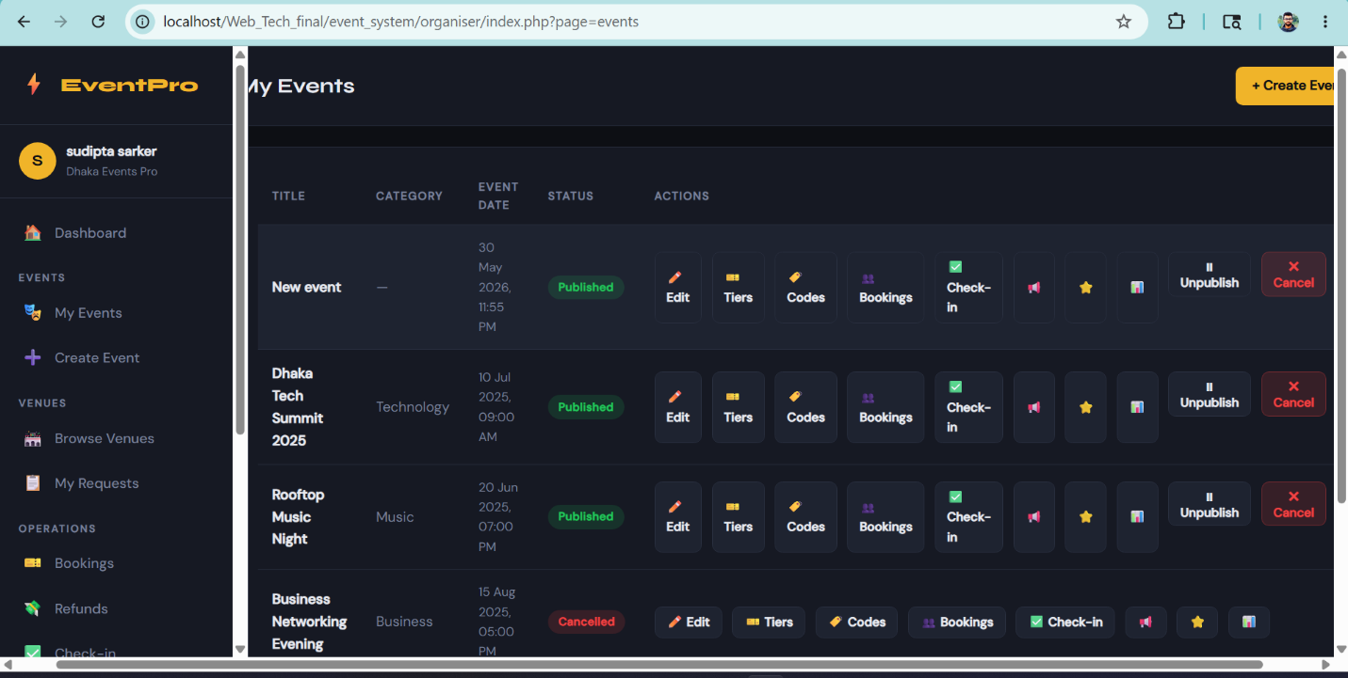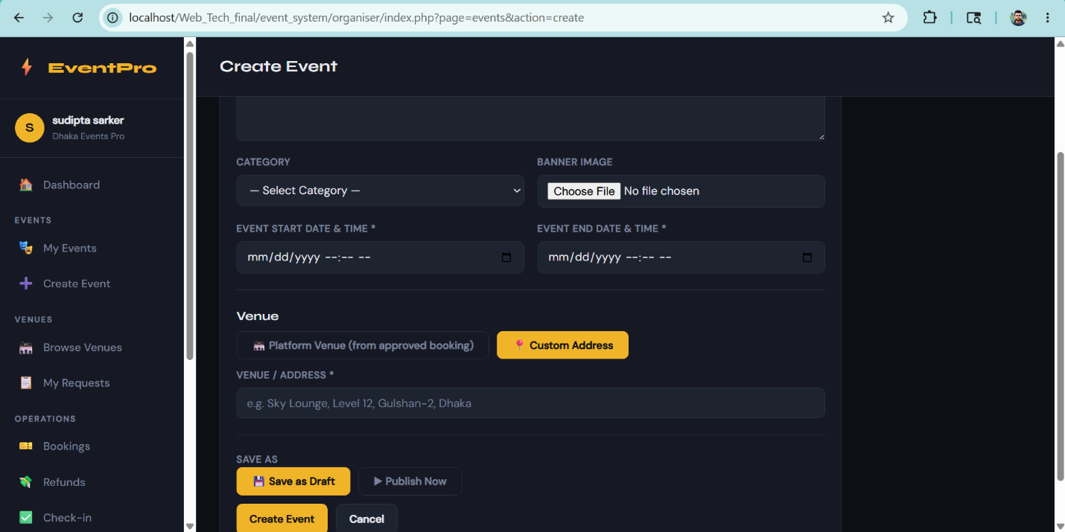[ Insert Screenshot Here — Right-click > Insert Picture ]

Feature: Ticket Tier Management
This feature allows organisers to create multiple ticket tiers for each event (e.g., General, VIP, Early Bird). Each tier has a name, description, price, total seat count, and optional sales start/end windows. Tiers can be edited at any time. A tier can only be deleted if no tickets have been sold for it the system checks the bookings table before allowing deletion. The manage page shows each tier alongside a live count of tickets sold, allowing the organiser to monitor availability at a glance.

Description
This feature allows organisers to create multiple ticket tiers for each event (e.g., General, VIP, Early Bird). Each tier has a name, description, price, total seat count, and optional sales start/end windows. Tiers can be edited at any time. A tier can only be deleted if no tickets have been sold for it — the system checks the bookings table before allowing deletion. The manage page shows each tier alongside a live count of tickets sold, allowing the organiser to monitor availability at a glance.

Relevant Source Code
File: /organiser/controllers/TierController.php
<?php
class TierController {

public function manage() {
$db = getDB();
$org_id = $_SESSION['user_id'];
$event_id = (int)($_GET['event_id'] ?? 0);

$stmt = $db->prepare("SELECT * FROM events WHERE id=? AND organiser_id=?");
$stmt->bind_param("ii", $event_id, $org_id);
$stmt->execute();
$event = $stmt->get_result()->fetch_assoc();
if (!$event) redirect('index.php?page=events');

$stmt2 = $db->prepare("SELECT t.*, (SELECT COUNT(*) FROM bookings b WHERE b.tier_id=t.id AND b.status='active') as sold FROM ticket_tiers t WHERE t.event_id=?");
$stmt2->bind_param("i", $event_id);
$stmt2->execute();
$tiers = $stmt2->get_result()->fetch_all(MYSQLI_ASSOC);
$flash = getFlash();
$db->close();
require 'views/tier/manage.php';
}

public function create() {
if (!isPost()) redirect('index.php?page=events');
$db = getDB();
$org_id = $_SESSION['user_id'];
$event_id = (int)($_POST['event_id'] ?? 0);

// Verify ownership
$stmt = $db->prepare("SELECT id FROM events WHERE id=? AND organiser_id=?");
$stmt->bind_param("ii", $event_id, $org_id);
$stmt->execute();
if (!$stmt->get_result()->fetch_assoc()) redirect('index.php?page=events');

$name = sanitize($_POST['name'] ?? '');
$description = sanitize($_POST['description'] ?? '');
$price = (float)($_POST['price'] ?? 0);
$total_seats = (int)($_POST['total_seats'] ?? 0);
$sales_start = $_POST['sales_start'] ?? '';
$sales_end = $_POST['sales_end'] ?? '';

if (!$name || $price < 0 || $total_seats < 1) {
setFlash('error', 'Invalid tier data.');
} else {
$stmt2 = $db->prepare("INSERT INTO ticket_tiers (event_id, name, description, price, total_seats, sales_start, sales_end) VALUES (?,?,?,?,?,?,?)");
$stmt2->bind_param("isssdss", $event_id, $name, $description, $price, $total_seats, $sales_start, $sales_end);
$stmt2->execute();
setFlash('success', 'Ticket tier added successfully!');
}
$db->close();
redirect('index.php?page=tiers&action=manage&event_id=' . $event_id);
}

public function edit() {
$db = getDB();
$org_id = $_SESSION['user_id'];
$tier_id = (int)($_GET['id'] ?? 0);

$stmt = $db->prepare("SELECT t.*, e.organiser_id FROM ticket_tiers t JOIN events e ON t.event_id=e.id WHERE t.id=? AND e.organiser_id=?");
$stmt->bind_param("ii", $tier_id, $org_id);
$stmt->execute();
$tier = $stmt->get_result()->fetch_assoc();
if (!$tier) redirect('index.php?page=events');

if (isPost()) {
$name = sanitize($_POST['name'] ?? '');
$description = sanitize($_POST['description'] ?? '');
$price = (float)($_POST['price'] ?? 0);
$total_seats = (int)($_POST['total_seats'] ?? 0);
$sales_start = $_POST['sales_start'] ?? '';
$sales_end = $_POST['sales_end'] ?? '';

$stmt2 = $db->prepare("UPDATE ticket_tiers SET name=?, description=?, price=?, total_seats=?, sales_start=?, sales_end=? WHERE id=?");
$stmt2->bind_param("ssdsssi", $name, $description, $price, $total_seats, $sales_start, $sales_end, $tier_id);
$stmt2->execute();
$db->close();
setFlash('success', 'Tier updated.');
redirect('index.php?page=tiers&action=manage&event_id=' . $tier['event_id']);
}
$db->close();
require 'views/tier/edit.php';
}

public function delete() {
if (!isPost()) redirect('index.php?page=events');
$db = getDB();
$org_id = $_SESSION['user_id'];
$tier_id = (int)($_POST['tier_id'] ?? 0);

$stmt = $db->prepare("SELECT t.*, e.organiser_id FROM ticket_tiers t JOIN events e ON t.event_id=e.id WHERE t.id=? AND e.organiser_id=?");
$stmt->bind_param("ii", $tier_id, $org_id);
$stmt->execute();
$tier = $stmt->get_result()->fetch_assoc();
if (!$tier) redirect('index.php?page=events');

// Check if tickets sold
$stmt2 = $db->prepare("SELECT COUNT(*) as cnt FROM bookings WHERE tier_id=? AND status='active'");
$stmt2->bind_param("i", $tier_id);
$stmt2->execute();
$cnt = $stmt2->get_result()->fetch_assoc()['cnt'];

if ($cnt > 0) {
setFlash('error', 'Cannot delete tier — tickets have already been sold.');
} else {
$stmt3 = $db->prepare("DELETE FROM ticket_tiers WHERE id=?");
$stmt3->bind_param("i", $tier_id);
$stmt3->execute();
setFlash('success', 'Tier deleted.');
}
$event_id = $tier['event_id'];
$db->close();
redirect('index.php?page=tiers&action=manage&event_id=' . $event_id);
}
}

Code Explanation
TierController::create() sanitizes and casts all input values to their correct types — price is cast to float and total_seats to int to prevent type-confusion attacks. Validation ensures the name is non-empty, price is not negative, and seat count is at least 1. The sales window fields are optional; if left blank, they are set to NULL so the tier is always on sale. The INSERT uses a prepared statement with bind_param() using "isssdss" as type string (i=int, s=string, d=double). The delete() method first queries the bookings table to count active tickets for the tier; if any exist, deletion is blocked and a flash error message is shown. This prevents data integrity issues where bookings would reference a non-existent tier. The manage() action also uses a subquery (SELECT COUNT(*) FROM bookings WHERE tier_id=t.id) to display real-time sold counts alongside each tier on the management page.

Screenshot(s)
Insert relevant screenshots of the UI for this feature below. Right-click > Insert Picture, or drag and drop.
[ Insert Screenshot Here — Right-click > Insert Picture ]

Feature: Real-Time AJAX Ticket Check-In
The Check-In feature allows an organiser to verify and check in attendees at an event in real time without a full page reload. The organiser enters a ticket code into a form on the check-in page. A vanilla JavaScript AJAX request (XMLHttpRequest) sends the code to the server-side ajaxCheckin() endpoint, which validates the ticket, verifies it belongs to the organiser's event, checks that it has not already been used, marks it as checked in, and returns a JSON response. The result (success or error) is displayed instantly on screen. Live check-in statistics are also updated after each successful scan.

Description
The Check-In feature allows an organiser to verify and check in attendees at an event in real time without a full page reload. The organiser enters a ticket code into a form on the check-in page. A vanilla JavaScript AJAX request (XMLHttpRequest) sends the code to the server-side ajaxCheckin() endpoint, which validates the ticket, verifies it belongs to the organiser's event, checks that it has not already been used, marks it as checked in, and returns a JSON response. The result (success or error) is displayed instantly on screen. Live check-in statistics are also updated after each successful scan.

Relevant Source Code
File: /organiser/public/js/main.js
function initCheckin() {
const form = document.getElementById('checkin-form');
if (!form) return;

form.addEventListener('submit', function(e) {
e.preventDefault();
const code = document.getElementById('ticket_code').value.trim();
const eventId = document.getElementById('event_id').value;
const btn = document.getElementById('checkin-btn');
const result = document.getElementById('checkin-result');

if (!code) { showCheckinResult(false, 'Please enter a ticket code.'); return; }

btn.disabled = true;
btn.textContent = 'Checking...';

const xhr = new XMLHttpRequest();
xhr.open('POST', 'index.php?page=api_checkin', true);
xhr.setRequestHeader('Content-Type', 'application/x-www-form-urlencoded');
xhr.onload = function() {
btn.disabled = false;
btn.textContent = 'Check In';
try {
const data = JSON.parse(xhr.responseText);
if (data.success) {
showCheckinResult(true,
`✅ Check-in Successful!\n${data.attendee} — ${data.tier} (×${data.quantity})\nTime: ${data.checked_in_at}`
);
document.getElementById('ticket_code').value = '';
updateStats();
} else {
showCheckinResult(false, '❌ ' + data.message);
}
} catch(err) {
showCheckinResult(false, 'Server error. Please try again.');
}
};
xhr.onerror = function() {
btn.disabled = false;
btn.textContent = 'Check In';
showCheckinResult(false, 'Network error. Please check your connection.');
};
xhr.send(`ticket_code=${encodeURIComponent(code)}&event_id=${encodeURIComponent(eventId)}`);
});
}

File: /organiser/controllers/CheckinController.php
public function ajaxCheckin() {
if (!isPost()) { jsonResponse(['success'=>false,'message'=>'Invalid request']); }

$db = getDB();
$org_id = $_SESSION['user_id'];
$ticket_code = sanitize($_POST['ticket_code'] ?? '');
$event_id = (int)($_POST['event_id'] ?? 0);

if (!$ticket_code) {
jsonResponse(['success'=>false,'message'=>'Please enter a ticket code.']);
}

// Verify ticket belongs to organiser's event
$stmt = $db->prepare("
SELECT b.*, u.name as attendee_name, t.name as tier_name, e.organiser_id
FROM bookings b
JOIN users u ON b.attendee_id=u.id
JOIN ticket_tiers t ON b.tier_id=t.id
JOIN events e ON b.event_id=e.id
WHERE b.ticket_code=? AND b.event_id=? AND e.organiser_id=?
");
$stmt->bind_param("sii", $ticket_code, $event_id, $org_id);
$stmt->execute();
$booking = $stmt->get_result()->fetch_assoc();

if (!$booking) {
jsonResponse(['success'=>false,'message'=>'Invalid ticket code. No booking found.']);
}

if ($booking['status'] !== 'active') {
jsonResponse(['success'=>false,'message'=>'Ticket is ' . $booking['status'] . ' and cannot be checked in.']);
}

if ($booking['checked_in']) {
jsonResponse([
'success' => false,
'message' => 'Ticket already checked in at ' . formatDate($booking['checked_in_at']) . '.',
'attendee' => $booking['attendee_name'],
'tier' => $booking['tier_name'],
]);
}

// Mark as checked in
$now = date('Y-m-d H:i:s');
$stmt2 = $db->prepare("UPDATE bookings SET checked_in=1, checked_in_at=? WHERE id=?");
$stmt2->bind_param("si", $now, $booking['id']);
$stmt2->execute();
$db->close();

jsonResponse([
'success' => true,
'message' => 'Check-in successful!',
'attendee' => $booking['attendee_name'],
'tier' => $booking['tier_name'],
'quantity' => $booking['quantity'],
'checked_in_at' => formatDate($now),
]);
}

Code Explanation
On the front end (main.js), the form's default submit is prevented with e.preventDefault(). An XMLHttpRequest is constructed, set to POST, and sends three URL-encoded parameters: ticket_code, event_id, and the CSRF token read from a hidden form field. The csrf_token is included to satisfy the server-side CSRF check even for AJAX requests. The onload callback parses the JSON response and calls showCheckinResult() to display success or error styling. On success, updateStats() makes a second GET AJAX request to refresh the live check-in counters. On the server side (CheckinController::ajaxCheckin()), the token is verified using hash_equals() for timing-safe comparison. The SQL JOIN query ensures the ticket belongs to the organiser's event (AND e.organiser_id=?), preventing one organiser from checking in another's tickets. If the ticket is already checked in, a descriptive message with the original check-in time is returned. On success, the bookings row is updated with checked_in=1 and the current timestamp, and a JSON object with attendee name, tier name, and quantity is returned to the client.

Screenshot(s)
Insert relevant screenshots of the UI for this feature below. Right-click > Insert Picture, or drag and drop.
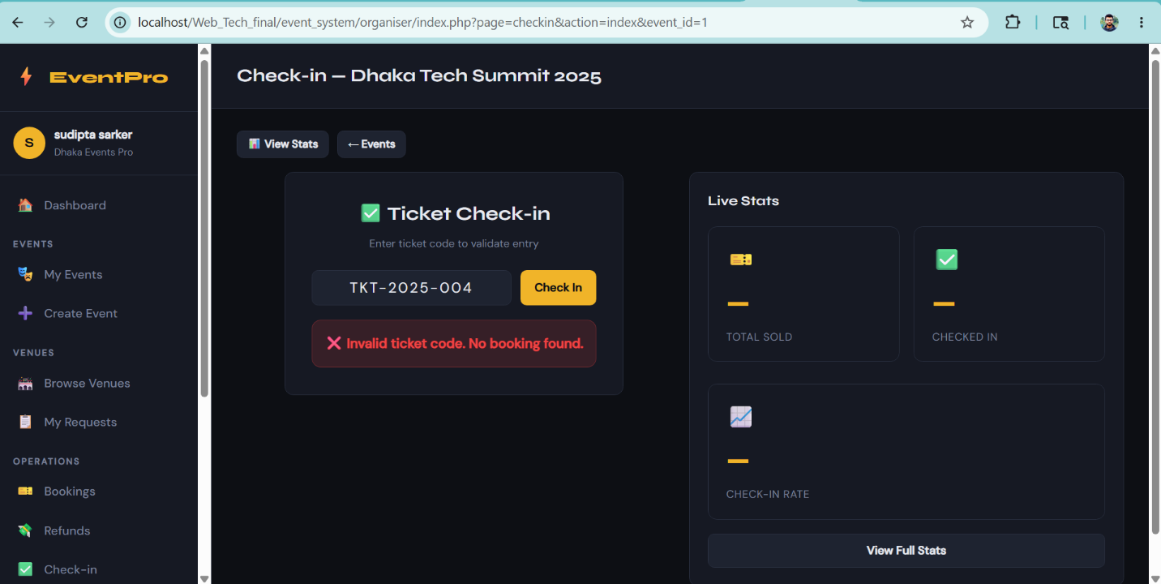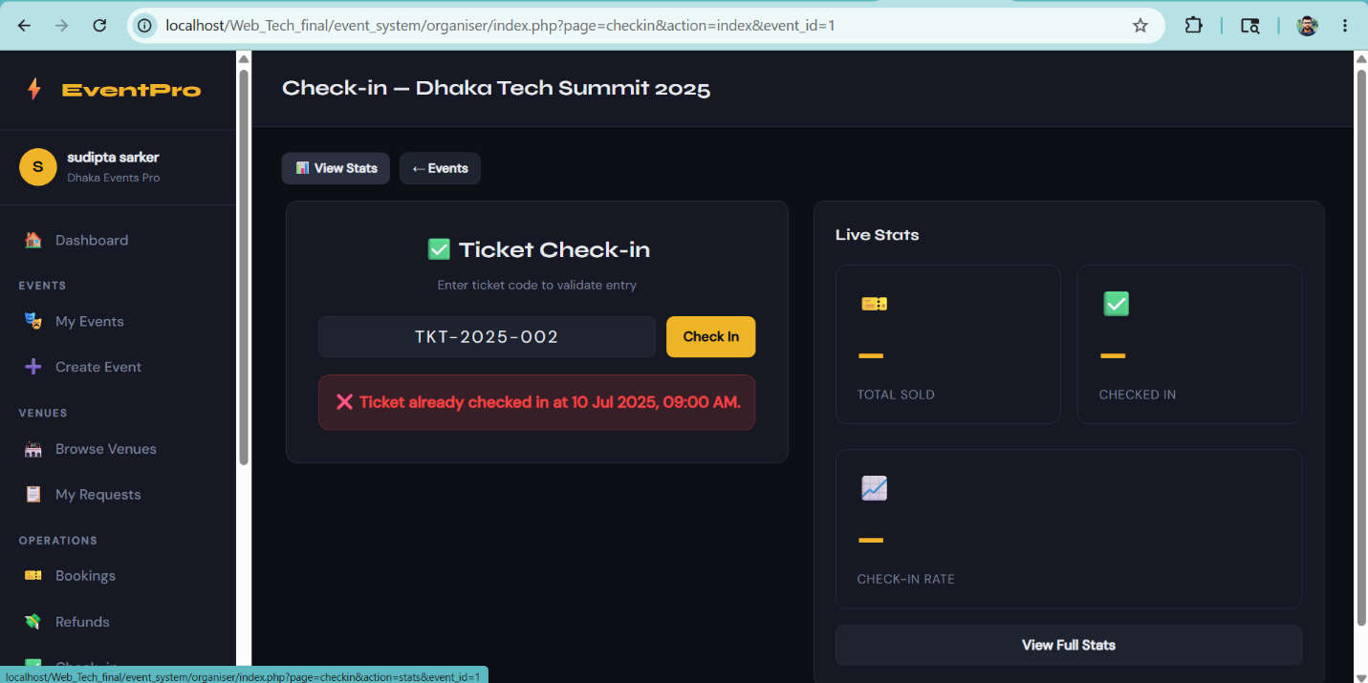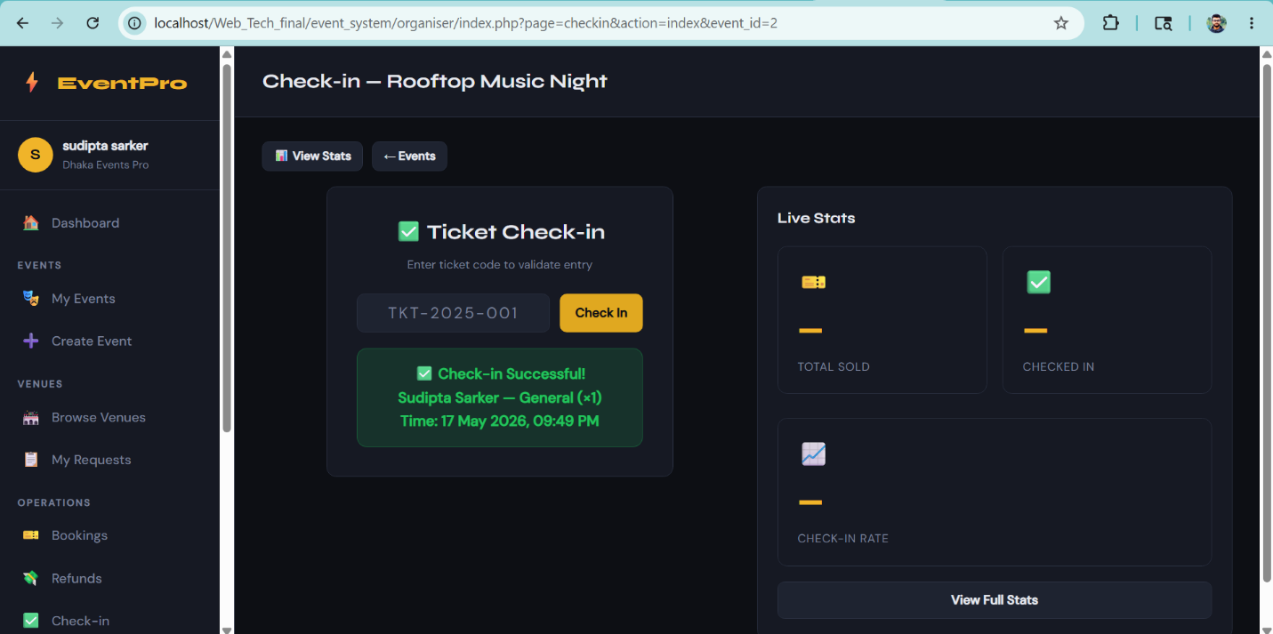[ Insert Screenshot Here — Right-click > Insert Picture ]

Feature: Refund Request Management
This feature allows organisers to review and process refund requests submitted by attendees. The refund list can be filtered by status (pending, approved, rejected). For each pending request, the organiser can approve or reject it with an optional note. Approving a refund automatically changes the associated booking status to "refunded", preventing double-processing. The system ensures only the event's organiser can process their own event's refund requests through an ownership verification query.

Description
This feature allows organisers to review and process refund requests submitted by attendees. The refund list can be filtered by status (pending, approved, rejected). For each pending request, the organiser can approve or reject it with an optional note. Approving a refund automatically changes the associated booking status to "refunded", preventing double-processing. The system ensures only the event's organiser can process their own event's refund requests through an ownership verification query.

Relevant Source Code
File: /organiser/controllers/RefundController.php
<?php
class RefundController {
public function index() {
$db = getDB();
$org_id = $_SESSION['user_id'];
$filter = $_GET['status'] ?? '';

$sql = "SELECT rr.*, b.ticket_code, b.total_price, e.title as event_title, u.name as attendee_name, u.email as attendee_email
FROM refund_requests rr
JOIN bookings b ON rr.booking_id=b.id
JOIN events e ON b.event_id=e.id
JOIN users u ON rr.attendee_id=u.id
WHERE e.organiser_id=?";
$params = [$org_id]; $types = 'i';
if ($filter) { $sql .= " AND rr.status=?"; $params[] = $filter; $types .= 's'; }
$sql .= " ORDER BY rr.created_at DESC";

$stmt = $db->prepare($sql);
$stmt->bind_param($types, ...$params);
$stmt->execute();
$refunds = $stmt->get_result()->fetch_all(MYSQLI_ASSOC);
$flash = getFlash();
$db->close();
require BASE_PATH . 'views/refund/index.php';
}

public function process() {
if (!isPost()) redirect('index.php?page=refunds');
$db = getDB();
$org_id = $_SESSION['user_id'];
$refund_id = (int)($_POST['refund_id'] ?? 0);
$action = $_POST['action'] ?? '';
$note = sanitize($_POST['organiser_note'] ?? '');

// Verify ownership
$stmt = $db->prepare("SELECT rr.* FROM refund_requests rr JOIN bookings b ON rr.booking_id=b.id JOIN events e ON b.event_id=e.id WHERE rr.id=? AND e.organiser_id=?");
$stmt->bind_param("ii", $refund_id, $org_id);
$stmt->execute();
$refund = $stmt->get_result()->fetch_assoc();
if (!$refund) redirect('index.php?page=refunds');

if ($action === 'approve') {
$status = 'approved';
// Mark booking as refunded
$stmt2 = $db->prepare("UPDATE bookings SET status='refunded' WHERE id=?");
$stmt2->bind_param("i", $refund['booking_id']);
$stmt2->execute();
} else {
$status = 'rejected';
}

$stmt3 = $db->prepare("UPDATE refund_requests SET status=?, organiser_note=? WHERE id=?");
$stmt3->bind_param("ssi", $status, $note, $refund_id);
$stmt3->execute();
$db->close();
setFlash('success', 'Refund request ' . $status . '.');
redirect('index.php?page=refunds');
}
}

Code Explanation
The process() method begins by calling verifyCsrfToken() to reject forged form submissions. The action field is validated against a whitelist ['approve', 'reject'] so only valid operations can be performed. The ownership verification JOIN query ensures the refund request belongs to a booking under an event owned by the currently logged-in organiser (e.organiser_id=?), preventing IDOR (Insecure Direct Object Reference) attacks. Before processing, the method checks that the refund status is still "pending" — this prevents the same refund from being processed twice (e.g., approved then rejected). If the action is "approve", the associated booking record is updated to status="refunded", which prevents the ticket from being checked in or used further. Finally, the refund_requests record is updated with the new status and the organiser's optional note. A flash message is set and the organiser is redirected back to the refunds list.

Screenshot(s)
Insert relevant screenshots of the UI for this feature below. Right-click > Insert Picture, or drag and drop.
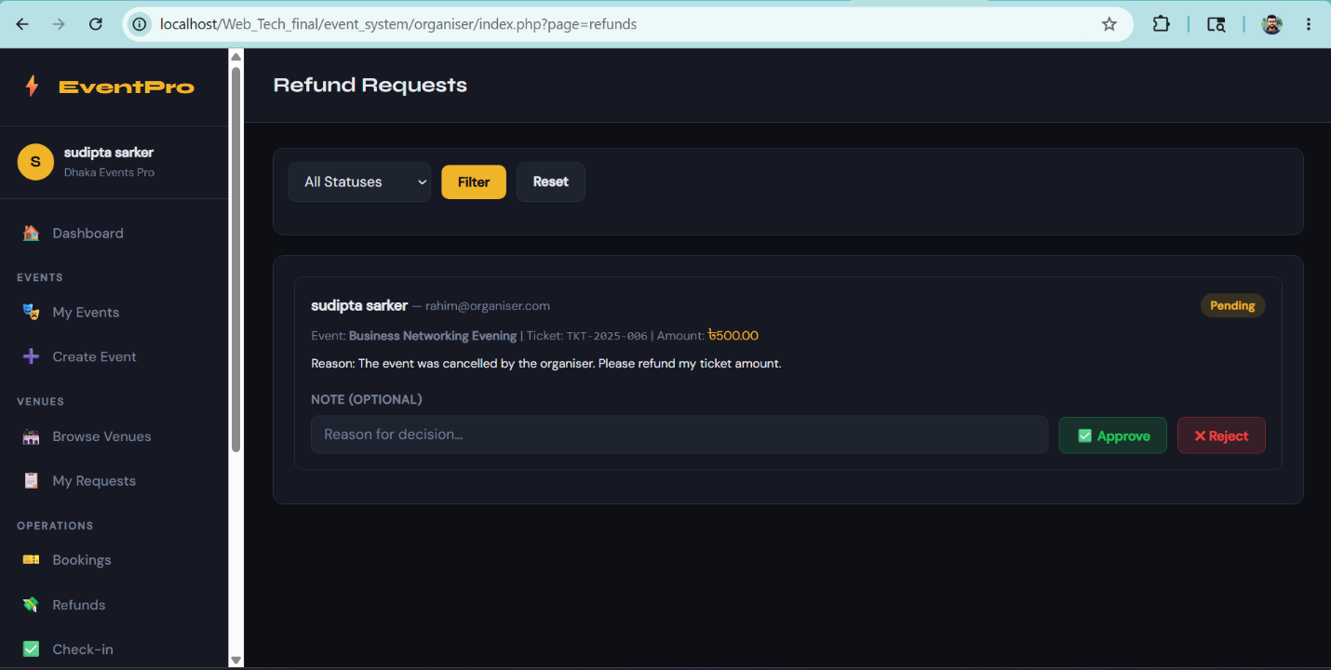[ Insert Screenshot Here — Right-click > Insert Picture ]

Feature: Discount Code Management
Organisers can create percentage-based discount codes for their events. Each discount code has a unique code string (automatically uppercased), a discount percentage (1–100%), a maximum usage count, and an optional expiry date. Codes can be activated or deactivated with a toggle. The feature includes both server-side PHP validation and client-side JavaScript validation to catch invalid inputs before form submission.

Description
Organisers can create percentage-based discount codes for their events. Each discount code has a unique code string (automatically uppercased), a discount percentage (1–100%), a maximum usage count, and an optional expiry date. Codes can be activated or deactivated with a toggle. The feature includes both server-side PHP validation and client-side JavaScript validation to catch invalid inputs before form submission.

Relevant Source Code
File: /organiser/controllers/DiscountController.php
<?php
class DiscountController {

public function index() {
$db = getDB();
$org_id = $_SESSION['user_id'];
$event_id = (int)($_GET['event_id'] ?? 0);

$stmt = $db->prepare("SELECT * FROM events WHERE id=? AND organiser_id=?");
$stmt->bind_param("ii", $event_id, $org_id);
$stmt->execute();
$event = $stmt->get_result()->fetch_assoc();
if (!$event) redirect('index.php?page=events');

$stmt2 = $db->prepare("SELECT * FROM discount_codes WHERE event_id=? AND organiser_id=? ORDER BY id DESC");
$stmt2->bind_param("ii", $event_id, $org_id);
$stmt2->execute();
$codes = $stmt2->get_result()->fetch_all(MYSQLI_ASSOC);
$flash = getFlash();
$db->close();
require BASE_PATH . 'views/discount/index.php';
}

public function create() {
if (!isPost()) redirect('index.php?page=events');
$db = getDB();
$org_id = $_SESSION['user_id'];
$event_id = (int)($_POST['event_id'] ?? 0);

$stmt = $db->prepare("SELECT id FROM events WHERE id=? AND organiser_id=?");
$stmt->bind_param("ii", $event_id, $org_id);
$stmt->execute();
if (!$stmt->get_result()->fetch_assoc()) redirect('index.php?page=events');

$code = strtoupper(sanitize($_POST['code'] ?? ''));
$discount_pct = (float)($_POST['discount_pct'] ?? 0);
$max_uses = (int)($_POST['max_uses'] ?? 1);
$valid_until = $_POST['valid_until'] ?? '';

if (!$code || $discount_pct <= 0 || $discount_pct > 100) {
setFlash('error', 'Invalid discount data.');
} else {
$stmt2 = $db->prepare("INSERT INTO discount_codes (event_id, organiser_id, code, discount_pct, max_uses, valid_until) VALUES (?,?,?,?,?,?)");
$stmt2->bind_param("iisdis", $event_id, $org_id, $code, $discount_pct, $max_uses, $valid_until);
$stmt2->execute();
setFlash('success', 'Discount code created!');
}
$db->close();
redirect('index.php?page=discounts&action=index&event_id=' . $event_id);
}

public function toggle() {
if (!isPost()) redirect('index.php?page=events');
$db = getDB();
$org_id = $_SESSION['user_id'];
$code_id = (int)($_POST['code_id'] ?? 0);
$event_id= (int)($_POST['event_id'] ?? 0);

$stmt = $db->prepare("UPDATE discount_codes SET is_active = NOT is_active WHERE id=? AND organiser_id=?");
$stmt->bind_param("ii", $code_id, $org_id);
$stmt->execute();
$db->close();
redirect('index.php?page=discounts&action=index&event_id=' . $event_id);
}
}

Code Explanation
The create() method applies strtoupper() on the discount code so codes are always stored as uppercase, preventing duplicates caused by case differences (e.g., "SAVE10" and "save10" treated as the same). The discount_pct is cast to float and validated to be between 1 and 100 inclusive. max_uses is cast to int and checked with isPositiveInt() (must be >= 1). The valid_until expiry date is optional — if the field is left empty, it is set to NULL so the code never expires. The INSERT uses a prepared statement with type string "iisdis" (i=event_id, i=organiser_id, s=code, d=discount_pct float, i=max_uses, s=valid_until). The toggle() action uses a single MySQL expression (SET is_active = NOT is_active) to atomically flip the active state without a separate SELECT query, and the WHERE clause includes AND organiser_id=? to prevent an organiser from toggling another organiser's discount codes.

Screenshot(s)
Insert relevant screenshots of the UI for this feature below. Right-click > Insert Picture, or drag and drop.
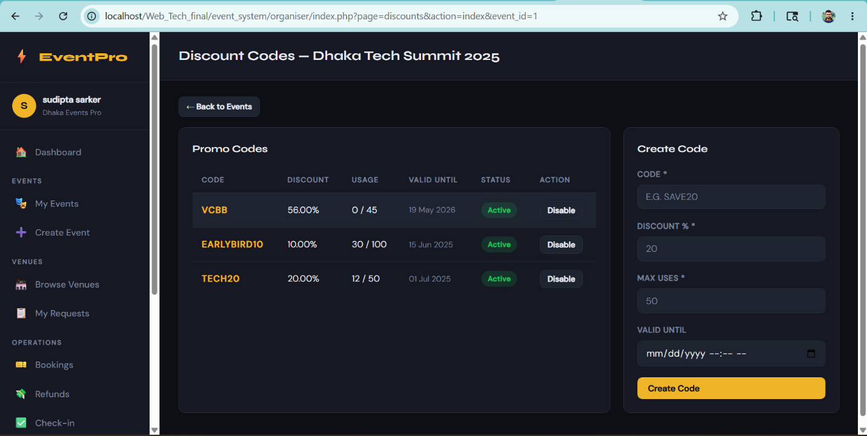[ Insert Screenshot Here — Right-click > Insert Picture ]

Feature: Event Announcements
The Announcements feature lets an organiser broadcast messages to all ticket holders of a specific event. Announcements are stored in the announcements table and listed in reverse chronological order. The organiser fills in a title and message body; both fields are validated on the server side. The sent_at timestamp is set automatically by the database. This feature is also used internally by the system to automatically send a cancellation notice when an event is cancelled.

Description
The Announcements feature lets an organiser broadcast messages to all ticket holders of a specific event. Announcements are stored in the announcements table and listed in reverse chronological order. The organiser fills in a title and message body; both fields are validated on the server side. The sent_at timestamp is set automatically by the database. This feature is also used internally by the system to automatically send a cancellation notice when an event is cancelled.

Relevant Source Code
File: /organiser/controllers/AnnouncementController.php
<?php
class AnnouncementController {
public function index() {
$db = getDB();
$org_id = $_SESSION['user_id'];
$event_id = (int)($_GET['event_id'] ?? 0);

$stmt = $db->prepare("SELECT * FROM events WHERE id=? AND organiser_id=?");
$stmt->bind_param("ii", $event_id, $org_id);
$stmt->execute();
$event = $stmt->get_result()->fetch_assoc();
if (!$event) redirect('index.php?page=events');

$stmt2 = $db->prepare("SELECT * FROM announcements WHERE event_id=? ORDER BY sent_at DESC");
$stmt2->bind_param("i", $event_id);
$stmt2->execute();
$announcements = $stmt2->get_result()->fetch_all(MYSQLI_ASSOC);
$flash = getFlash();
$db->close();
require BASE_PATH . 'views/announcement/index.php';
}

public function send() {
if (!isPost()) redirect('index.php?page=events');
$db = getDB();
$org_id = $_SESSION['user_id'];
$event_id = (int)($_POST['event_id'] ?? 0);
$title = sanitize($_POST['title'] ?? '');
$body = sanitize($_POST['body'] ?? '');

$stmt = $db->prepare("SELECT id FROM events WHERE id=? AND organiser_id=?");
$stmt->bind_param("ii", $event_id, $org_id);
$stmt->execute();
if (!$stmt->get_result()->fetch_assoc()) redirect('index.php?page=events');

if (!$title || !$body) {
setFlash('error', 'Title and body are required.');
} else {
$stmt2 = $db->prepare("INSERT INTO announcements (event_id, organiser_id, title, body) VALUES (?,?,?,?)");
$stmt2->bind_param("iiss", $event_id, $org_id, $title, $body);
$stmt2->execute();
setFlash('success', 'Announcement sent to all ticket holders!');
}
$db->close();
redirect('index.php?page=announcements&action=index&event_id=' . $event_id);
}
}

Code Explanation
The send() method begins with a CSRF token check to prevent unauthorised POST requests. Both title and body are processed through sanitize() to strip any HTML/script tags before storage, preventing stored XSS attacks. The isValidLength() helper is used to check: (1) the title is non-empty, (2) the body is non-empty, and (3) the title does not exceed 200 characters. These are validated in order, stopping at the first failure and displaying the appropriate flash error message. A prior ownership check on the event ensures the organiser can only post announcements for their own events. The INSERT uses a prepared statement binding event_id, organiser_id, title, and body. The sent_at column uses the database default (CURRENT_TIMESTAMP) so no PHP timestamp manipulation is needed. On success, a flash success message is set and the organiser is redirected back to the announcements page.

Screenshot(s)
Insert relevant screenshots of the UI for this feature below. Right-click > Insert Picture, or drag and drop.
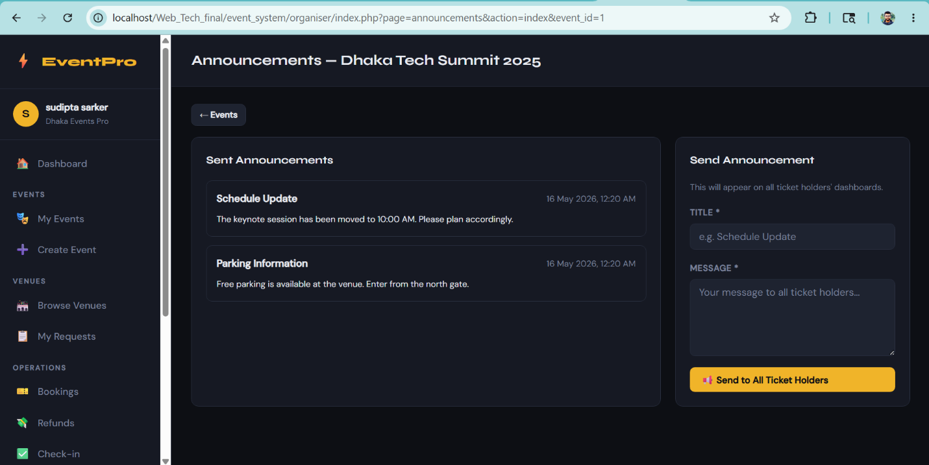[ Insert Screenshot Here — Right-click > Insert Picture ]

Feature: Event Analytics Dashboard
The Analytics feature provides an organiser with a comprehensive performance overview for a specific event. It shows total bookings, total tickets sold, total revenue, and occupancy rate (percentage of total seats filled). A revenue breakdown per ticket tier is displayed. A time-series of daily ticket sales and revenue is computed for trend analysis. Finally, repeat attendees (users who have attended more than one of the organiser's events) are listed, helping the organiser identify loyal customers.

Description
The Analytics feature provides an organiser with a comprehensive performance overview for a specific event. It shows total bookings, total tickets sold, total revenue, and occupancy rate (percentage of total seats filled). A revenue breakdown per ticket tier is displayed. A time-series of daily ticket sales and revenue is computed for trend analysis. Finally, repeat attendees (users who have attended more than one of the organiser's events) are listed, helping the organiser identify loyal customers.

Relevant Source Code
File: /organiser/controllers/AnalyticsController.php
<?php
class AnalyticsController {
public function index() {
$db = getDB();
$org_id = $_SESSION['user_id'];
$event_id = (int)($_GET['event_id'] ?? 0);

// Validation
if ($event_id <= 0) {
redirect('index.php?page=events');
}

$stmt = $db->prepare("SELECT * FROM events WHERE id=? AND organiser_id=?");
$stmt->bind_param("ii", $event_id, $org_id);
$stmt->execute();
$event = $stmt->get_result()->fetch_assoc();
if (!$event) redirect('index.php?page=events');

// Total revenue & tickets
$stmt2 = $db->prepare("SELECT COUNT(*) as total_bookings, SUM(quantity) as total_tickets, SUM(total_price) as total_revenue FROM bookings WHERE event_id=? AND status='active'");
$stmt2->bind_param("i", $event_id);
$stmt2->execute();
$summary = $stmt2->get_result()->fetch_assoc();

// Revenue per tier
$stmt3 = $db->prepare("SELECT t.name, t.total_seats, t.price, COUNT(b.id) as bookings_count, SUM(b.quantity) as sold, SUM(b.total_price) as revenue FROM ticket_tiers t LEFT JOIN bookings b ON b.tier_id=t.id AND b.status='active' WHERE t.event_id=? GROUP BY t.id");
$stmt3->bind_param("i", $event_id);
$stmt3->execute();
$tierRevenue = $stmt3->get_result()->fetch_all(MYSQLI_ASSOC);

// Ticket sales over time (daily)
$stmt4 = $db->prepare("SELECT DATE(created_at) as sale_date, SUM(quantity) as tickets_sold, SUM(total_price) as revenue FROM bookings WHERE event_id=? AND status='active' GROUP BY DATE(created_at) ORDER BY sale_date ASC");
$stmt4->bind_param("i", $event_id);
$stmt4->execute();
$salesOverTime = $stmt4->get_result()->fetch_all(MYSQLI_ASSOC);

// Occupancy rate
$stmt5 = $db->prepare("SELECT SUM(total_seats) as total_capacity FROM ticket_tiers WHERE event_id=?");
$stmt5->bind_param("i", $event_id);
$stmt5->execute();
$capacity = $stmt5->get_result()->fetch_assoc()['total_capacity'] ?? 0;
$occupancyRate = $capacity > 0 ? round(($summary['total_tickets'] / $capacity) * 100, 1) : 0;

// Repeat attendees
$stmt6 = $db->prepare("
SELECT u.name, u.email, COUNT(DISTINCT b.event_id) as events_attended
FROM bookings b
JOIN events e ON b.event_id=e.id
JOIN users u ON b.attendee_id=u.id
WHERE e.organiser_id=? AND b.status='active'
GROUP BY b.attendee_id
HAVING events_attended > 1
ORDER BY events_attended DESC
LIMIT 10
");
$stmt6->bind_param("i", $org_id);
$stmt6->execute();
$repeatAttendees = $stmt6->get_result()->fetch_all(MYSQLI_ASSOC);

$db->close();
require BASE_PATH . 'views/analytics/index.php';
}
}

Code Explanation
Query 1 uses COUNT(*) and SUM() aggregates on the bookings table filtered by event_id and status="active" to compute overall booking volume and revenue in a single round trip. Query 2 uses a LEFT JOIN between ticket_tiers and bookings with GROUP BY t.id so that tiers with no bookings still appear in the result (with zero revenue), giving a complete picture. Query 3 uses DATE(created_at) to truncate timestamps to just the date and GROUP BY that date to produce a daily sales time-series, ordered ascending for correct chart display. The occupancy rate is computed in PHP by dividing total tickets sold by total seat capacity (summed across all tiers) and multiplying by 100; division by zero is protected with a ternary check. Query 5 uses COUNT(DISTINCT b.event_id) to count unique events per attendee across all of the organiser's events, filtered to those who attended more than one (HAVING events_attended > 1), and limited to the top 10. All queries use prepared statements with organiser-scoped filters to ensure no cross-organiser data leakage.

Screenshot(s)
Insert relevant screenshots of the UI for this feature below. Right-click > Insert Picture, or drag and drop.
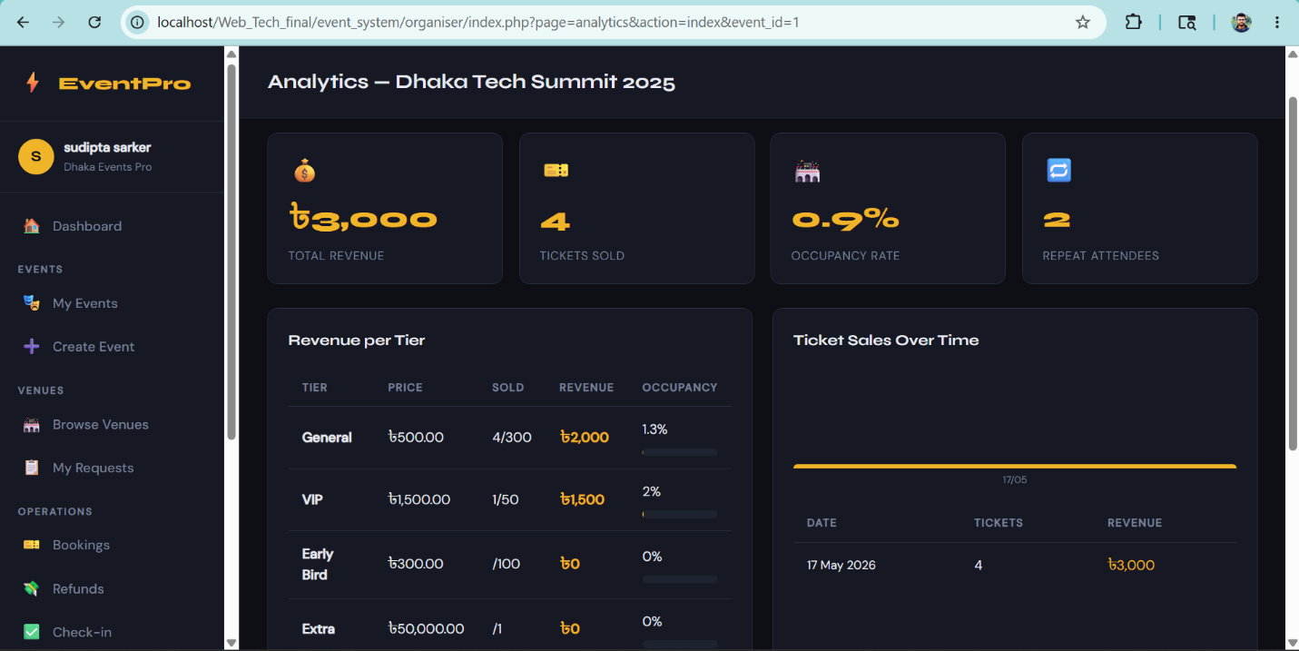[ Insert Screenshot Here — Right-click > Insert Picture ]

Feature: Venue Browsing & Booking Request
The Venue feature allows organisers to browse all active venues listed on the platform, search and filter by name, city, or facility keyword. Clicking a venue shows its full detail page including pricing tiers and a 60-day availability calendar. From the detail page, the organiser can submit a booking request by providing an event title preview, requested dates (comma-separated), and a message. The organiser can also view all their submitted venue requests and their approval status.

Description
The Venue feature allows organisers to browse all active venues listed on the platform, search and filter by name, city, or facility keyword. Clicking a venue shows its full detail page including pricing tiers and a 60-day availability calendar. From the detail page, the organiser can submit a booking request by providing an event title preview, requested dates (comma-separated), and a message. The organiser can also view all their submitted venue requests and their approval status.

Relevant Source Code
File: /organiser/controllers/VenueController.php
<?php
class VenueController {

public function index() {
$db = getDB();
$search = sanitize($_GET['search'] ?? '');
$city = sanitize($_GET['city'] ?? '');
$facility = sanitize($_GET['facility'] ?? '');

$sql = "SELECT v.*, u.name as manager_name FROM venues v JOIN users u ON v.manager_id=u.id WHERE v.is_active=1";
$params = []; $types = '';

if ($search) { $sql .= " AND v.name LIKE ?"; $params[] = "%$search%"; $types .= 's'; }
if ($city) { $sql .= " AND v.city LIKE ?"; $params[] = "%$city%"; $types .= 's'; }
if ($facility){ $sql .= " AND v.facilities LIKE ?"; $params[] = "%$facility%"; $types .= 's'; }

$stmt = $db->prepare($sql);
if ($params) { $stmt->bind_param($types, ...$params); }
$stmt->execute();
$venues = $stmt->get_result()->fetch_all(MYSQLI_ASSOC);
$db->close();
require 'views/venue/index.php';
}

public function detail() {
$venue_id = (int)($_GET['id'] ?? 0);
$db = getDB();

$stmt = $db->prepare("SELECT v.*, u.name as manager_name FROM venues v JOIN users u ON v.manager_id=u.id WHERE v.id=?");
$stmt->bind_param("i", $venue_id);
$stmt->execute();
$venue = $stmt->get_result()->fetch_assoc();
if (!$venue) { redirect('index.php?page=venues'); }

$stmt2 = $db->prepare("SELECT * FROM venue_pricing WHERE venue_id=?");
$stmt2->bind_param("i", $venue_id);
$stmt2->execute();
$pricing = $stmt2->get_result()->fetch_all(MYSQLI_ASSOC);

// Availability for next 60 days
$stmt3 = $db->prepare("SELECT * FROM venue_availability WHERE venue_id=? AND date >= CURDATE() AND date <= DATE_ADD(CURDATE(), INTERVAL 60 DAY)");
$stmt3->bind_param("i", $venue_id);
$stmt3->execute();
$availability = $stmt3->get_result()->fetch_all(MYSQLI_ASSOC);

$db->close();
require 'views/venue/detail.php';
}

public function bookingRequest() {
$venue_id = (int)($_GET['id'] ?? 0);
$db = getDB();
$stmt = $db->prepare("SELECT * FROM venues WHERE id=? AND is_active=1");
$stmt->bind_param("i", $venue_id);
$stmt->execute();
$venue = $stmt->get_result()->fetch_assoc();
if (!$venue) redirect('index.php?page=venues');

$error = null;
if (isPost()) {
$title = sanitize($_POST['event_title_preview'] ?? '');
$dates = $_POST['requested_dates'] ?? '';
$message = sanitize($_POST['message'] ?? '');
$dateArr = array_filter(array_map('trim', explode(',', $dates)));

if (!$title || !$dates || !$message) {
$error = 'Please fill all fields.';
} else {
$datesJson = json_encode($dateArr);
$org_id = $_SESSION['user_id'];
$stmt2 = $db->prepare("INSERT INTO venue_booking_requests (venue_id, organiser_id, event_title_preview, requested_dates, message) VALUES (?,?,?,?,?)");
$stmt2->bind_param("iisss", $venue_id, $org_id, $title, $datesJson, $message);
$stmt2->execute();
$db->close();
setFlash('success', 'Booking request submitted successfully!');
redirect('index.php?page=venues&action=myRequests');
}
}
$db->close();
require 'views/venue/booking_request.php';
}

public function myRequests() {
$db = getDB();
$org_id = $_SESSION['user_id'];
$stmt = $db->prepare("SELECT vbr.*, v.name as venue_name, v.city FROM venue_booking_requests vbr JOIN venues v ON vbr.venue_id=v.id WHERE vbr.organiser_id=? ORDER BY vbr.submitted_at DESC");
$stmt->bind_param("i", $org_id);
$stmt->execute();
$requests = $stmt->get_result()->fetch_all(MYSQLI_ASSOC);
$db->close();
require 'views/venue/my_requests.php';
}
}

Code Explanation
VenueController::index() builds a dynamic SQL query by conditionally appending WHERE clauses based on which search parameters are present. The $params array and $types string are built in parallel, and bind_param() is called with the spread operator (...$params) only when there are filters — this handles the case of no filters gracefully without a runtime error. All search values are wrapped in LIKE "%...%" for partial matching and are passed as bound parameters, never interpolated directly into the SQL string, preventing SQL injection. The detail() method queries venue_availability to show availability only for the next 60 days (using DATE_ADD(CURDATE(), INTERVAL 60 DAY)), keeping the result set small and relevant. In bookingRequest(), the comma-separated dates string is split into an array with array_filter() and array_map(), then encoded as JSON using json_encode() and stored in a single column, allowing flexible multi-date requests. After a successful submission, the organiser is redirected to the myRequests() page to see the pending status.

Screenshot(s)
Insert relevant screenshots of the UI for this feature below. Right-click > Insert Picture, or drag and drop.
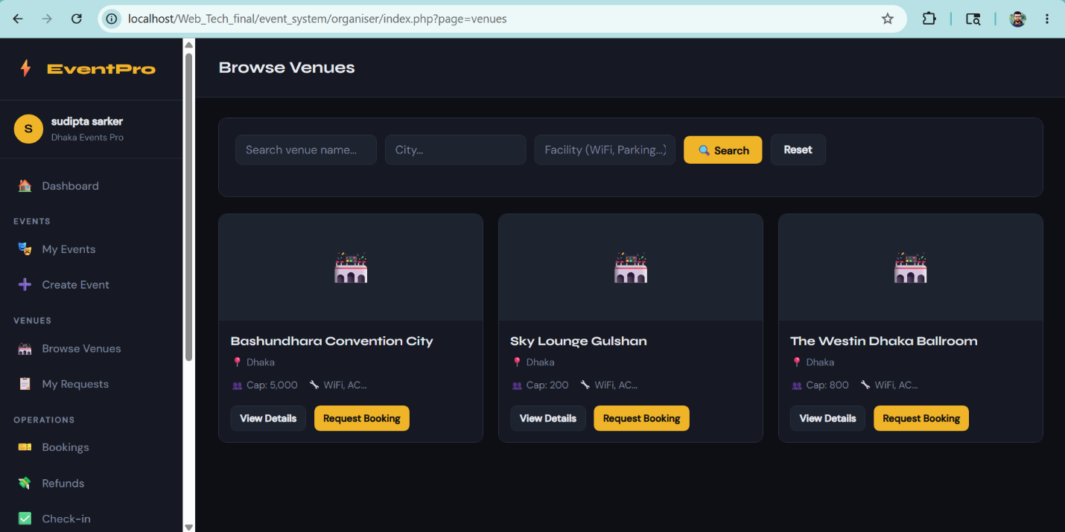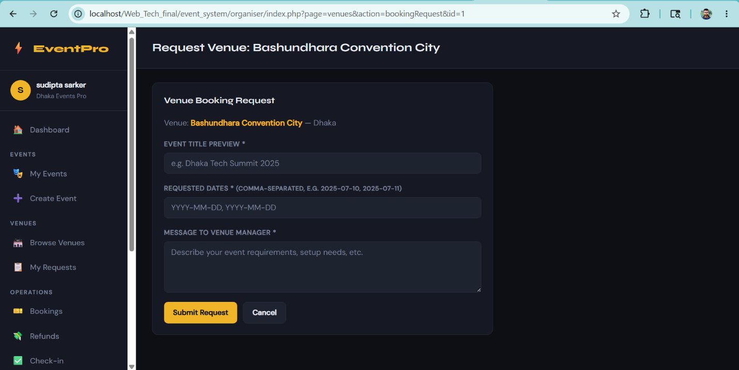[ Insert Screenshot Here — Right-click > Insert Picture ]

Feature: Attendee Review Viewing & Organiser Reply
After an event, attendees can leave star ratings and written reviews. This feature allows organisers to view all reviews for a specific event and post a reply to each one. The organiser's reply is validated for length (1–1000 characters) and stored in the organiser_reply column of the event_reviews table. Ownership is verified through a JOIN query before allowing any reply to be saved.

Description
After an event, attendees can leave star ratings and written reviews. This feature allows organisers to view all reviews for a specific event and post a reply to each one. The organiser's reply is validated for length (1–1000 characters) and stored in the organiser_reply column of the event_reviews table. Ownership is verified through a JOIN query before allowing any reply to be saved.

Relevant Source Code
File: /organiser/controllers/ReviewController.php
<?php
class ReviewController {
public function index() {
$db = getDB();
$org_id = $_SESSION['user_id'];
$event_id = (int)($_GET['event_id'] ?? 0);

$stmt = $db->prepare("SELECT * FROM events WHERE id=? AND organiser_id=?");
$stmt->bind_param("ii", $event_id, $org_id);
$stmt->execute();
$event = $stmt->get_result()->fetch_assoc();
if (!$event) redirect('index.php?page=events');

$stmt2 = $db->prepare("SELECT r.*, u.name as attendee_name FROM event_reviews r JOIN users u ON r.attendee_id=u.id WHERE r.event_id=? ORDER BY r.created_at DESC");
$stmt2->bind_param("i", $event_id);
$stmt2->execute();
$reviews = $stmt2->get_result()->fetch_all(MYSQLI_ASSOC);
$flash = getFlash();
$db->close();
require BASE_PATH .'views/review/index.php';
}

public function reply() {
if (!isPost()) redirect('index.php?page=events');
$db = getDB();
$org_id = $_SESSION['user_id'];
$review_id = (int)($_POST['review_id'] ?? 0);
$reply = sanitize($_POST['organiser_reply'] ?? '');
$event_id = (int)($_POST['event_id'] ?? 0);

$stmt = $db->prepare("SELECT r.* FROM event_reviews r JOIN events e ON r.event_id=e.id WHERE r.id=? AND e.organiser_id=?");
$stmt->bind_param("ii", $review_id, $org_id);
$stmt->execute();
if (!$stmt->get_result()->fetch_assoc()) redirect('index.php?page=events');

$stmt2 = $db->prepare("UPDATE event_reviews SET organiser_reply=? WHERE id=?");
$stmt2->bind_param("si", $reply, $review_id);
$stmt2->execute();
$db->close();
setFlash('success', 'Reply posted.');
redirect('index.php?page=reviews&action=index&event_id=' . $event_id);
}
}

Code Explanation
ReviewController::index() fetches all reviews for the given event using a JOIN with the users table to include the attendee's name, ordered by most recent first. Before displaying the reviews page, the system verifies the event belongs to the logged-in organiser using a separate ownership query. The reply() method first checks the CSRF token, then sanitizes the reply text to prevent XSS. Length validation is applied in two steps: first checking the reply is non-empty (isValidLength without max), then checking it does not exceed 1000 characters (isValidLength(1, 1000)). A JOIN ownership query confirms the review belongs to one of the organiser's events before any UPDATE is executed, preventing an organiser from replying to reviews on other organisers' events (IDOR protection). The UPDATE uses a prepared statement, setting organiser_reply to the sanitized text. A flash success message is shown and the organiser is redirected back to the reviews page.

Screenshot(s)
Insert relevant screenshots of the UI for this feature below. Right-click > Insert Picture, or drag and drop.
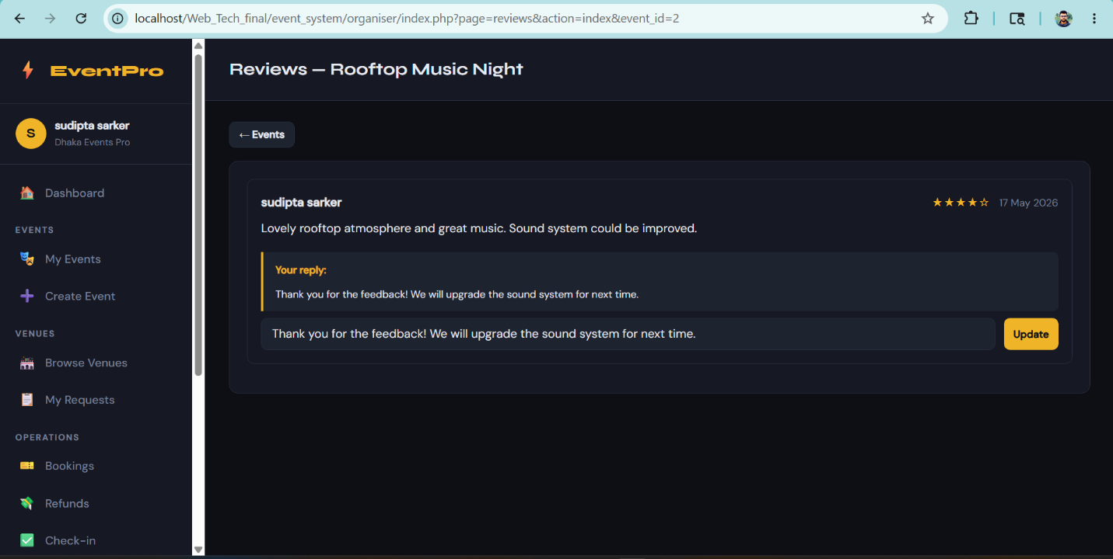[ Insert Screenshot Here — Right-click > Insert Picture ]

Feature: Organiser Profile Management
The Profile feature allows an organiser to update their personal details (name, phone) and organisation information (organisation name, description, website URL, logo image). A separate form allows changing the account password with current-password verification. All changes are reflected immediately in the session variables for the name and organisation name. The feature uses CSRF protection on all POST forms and validates URL format for the website field.

Description
The Profile feature allows an organiser to update their personal details (name, phone) and organisation information (organisation name, description, website URL, logo image). A separate form allows changing the account password with current-password verification. All changes are reflected immediately in the session variables for the name and organisation name. The feature uses CSRF protection on all POST forms and validates URL format for the website field.

Relevant Source Code
File: /organiser/controllers/ProfileController.php
<?php
require_once 'models/UserModel.php';
require_once 'models/OrganiserModel.php';

class ProfileController {
public function index() {
$user = UserModel::findById($_SESSION['user_id']);
$profile = OrganiserModel::getProfileByUserId($_SESSION['user_id']);
$flash = getFlash();
require 'views/profile/index.php';
}

public function update() {
if (!isPost()) redirect('index.php?page=profile');
$db = getDB();
$uid = $_SESSION['user_id'];

$name = sanitize($_POST['name'] ?? '');
$phone = sanitize($_POST['phone'] ?? '');
$org_name= sanitize($_POST['org_name'] ?? '');
$org_desc= sanitize($_POST['org_description'] ?? '');
$website = sanitize($_POST['website'] ?? '');

// Update user
$stmt = $db->prepare("UPDATE users SET name=?, phone=? WHERE id=?");
$stmt->bind_param("ssi", $name, $phone, $uid);
$stmt->execute();

// Handle logo upload
$logo_sql = "";
$logo_path = null;
if (!empty($_FILES['org_logo']['name'])) {
$logo_path = uploadFile($_FILES['org_logo'], 'public/uploads/');
if ($logo_path) {
$stmt2 = $db->prepare("UPDATE organiser_profiles SET org_name=?, org_description=?, website=?, org_logo_path=? WHERE user_id=?");
$stmt2->bind_param("ssssi", $org_name, $org_desc, $website, $logo_path, $uid);
$stmt2->execute();
}
} else {
$stmt2 = $db->prepare("UPDATE organiser_profiles SET org_name=?, org_description=?, website=? WHERE user_id=?");
$stmt2->bind_param("sssi", $org_name, $org_desc, $website, $uid);
$stmt2->execute();
}

$_SESSION['name'] = $name;
$_SESSION['org_name'] = $org_name;
$db->close();
setFlash('success', 'Profile updated successfully.');
redirect('index.php?page=profile');
}

public function changePassword() {
if (!isPost()) redirect('index.php?page=profile');
$uid = $_SESSION['user_id'];
$current = $_POST['current_password'] ?? '';
$new = $_POST['new_password'] ?? '';
$confirm = $_POST['confirm_password'] ?? '';

$user = UserModel::findById($uid);
if (!password_verify($current, $user['password_hash'])) {
setFlash('error', 'Current password is incorrect.');
} elseif (strlen($new) < 6) {
setFlash('error', 'New password must be at least 6 characters.');
} elseif ($new !== $confirm) {
setFlash('error', 'Passwords do not match.');
} else {
$hash = password_hash($new, PASSWORD_BCRYPT);
$db = getDB();
$stmt = $db->prepare("UPDATE users SET password_hash=? WHERE id=?");
$stmt->bind_param("si", $hash, $uid);
$stmt->execute();
$db->close();
setFlash('success', 'Password changed successfully.');
}
redirect('index.php?page=profile');
}
}

Code Explanation
The update() method sanitizes all input fields and validates the website URL using PHP's built-in filter_var() with FILTER_VALIDATE_URL, which rejects malformed URLs. If a new logo image is uploaded, uploadFile() validates the file type; otherwise, the existing logo is preserved. After a successful save, the session variables $_SESSION["name"] and $_SESSION["org_name"] are updated immediately so the navbar reflects the new name without requiring a re-login. The changePassword() method retrieves the current user record and calls password_verify() to confirm the submitted current password matches the stored bcrypt hash — this prevents an attacker who gains temporary access to the browser from changing the password without knowing it. The new password is checked to be at least 6 characters and confirmed to match the confirmation field. Finally, password_hash() with PASSWORD_BCRYPT generates a new secure hash which is stored via a prepared statement UPDATE.

Screenshot(s)
Insert relevant screenshots of the UI for this feature below. Right-click > Insert Picture, or drag and drop.
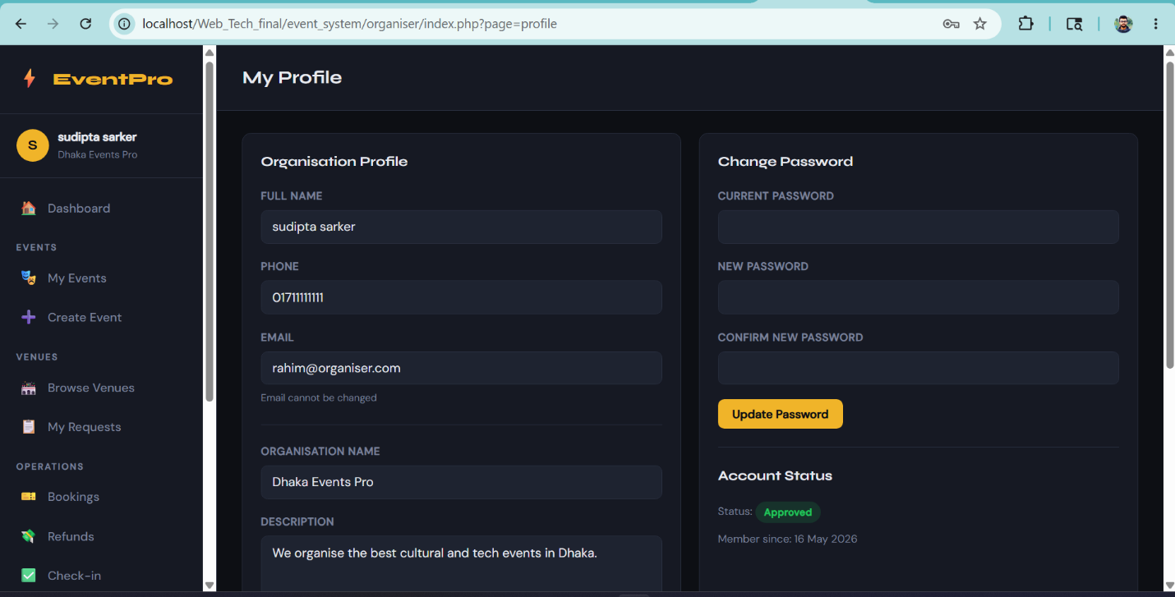[ Insert Screenshot Here — Right-click > Insert Picture ]

Feature: Client-Side JavaScript Form Validation
All major forms in the application include client-side validation using vanilla JavaScript (no libraries). Validation is attached to form submit events using addEventListener. Errors are displayed inline next to each field using dedicated error span elements (id="err-fieldname"). If any field fails validation, e.preventDefault() stops the form from submitting. The validated forms include Login, Register, Event Create/Edit, Ticket Tier, Announcement, and Discount Code forms. This provides instant feedback to users and reduces unnecessary server round-trips.

Description
All major forms in the application include client-side validation using vanilla JavaScript (no libraries). Validation is attached to form submit events using addEventListener. Errors are displayed inline next to each field using dedicated error span elements (id="err-fieldname"). If any field fails validation, e.preventDefault() stops the form from submitting. The validated forms include Login, Register, Event Create/Edit, Ticket Tier, Announcement, and Discount Code forms. This provides instant feedback to users and reduces unnecessary server round-trips.

Relevant Source Code
File: /organiser/public/js/main.js
// EventPro Organiser — Main JS

// ========== Check-in AJAX ==========
function initCheckin() {
const form = document.getElementById('checkin-form');
if (!form) return;

form.addEventListener('submit', function(e) {
e.preventDefault();
const code = document.getElementById('ticket_code').value.trim();
const eventId = document.getElementById('event_id').value;
const btn = document.getElementById('checkin-btn');
const result = document.getElementById('checkin-result');

if (!code) { showCheckinResult(false, 'Please enter a ticket code.'); return; }

btn.disabled = true;
btn.textContent = 'Checking...';

const xhr = new XMLHttpRequest();
xhr.open('POST', 'index.php?page=api_checkin', true);
xhr.setRequestHeader('Content-Type', 'application/x-www-form-urlencoded');
xhr.onload = function() {
btn.disabled = false;
btn.textContent = 'Check In';
try {
const data = JSON.parse(xhr.responseText);
if (data.success) {
showCheckinResult(true,
`✅ Check-in Successful!\n${data.attendee} — ${data.tier} (×${data.quantity})\nTime: ${data.checked_in_at}`
);
document.getElementById('ticket_code').value = '';
updateStats();
} else {
showCheckinResult(false, '❌ ' + data.message);
}
} catch(err) {
showCheckinResult(false, 'Server error. Please try again.');
}
};
xhr.onerror = function() {
btn.disabled = false;
btn.textContent = 'Check In';
showCheckinResult(false, 'Network error. Please check your connection.');
};
xhr.send(`ticket_code=${encodeURIComponent(code)}&event_id=${encodeURIComponent(eventId)}`);
});
}

function showCheckinResult(success, message) {
const el = document.getElementById('checkin-result');
el.className = success ? 'success' : 'error';
el.style.whiteSpace = 'pre-line';
el.textContent = message;
}

function updateStats() {
const statsEl = document.getElementById('live-stats');
if (!statsEl) return;
const eventId = document.getElementById('event_id').value;
const xhr = new XMLHttpRequest();
xhr.open('GET', `index.php?page=checkin&action=stats&event_id=${eventId}&ajax=1`, true);
xhr.onload = function() {
try {
const d = JSON.parse(xhr.responseText);
if (d.total_sold !== undefined) {
document.getElementById('stat-sold').textContent = d.total_sold;
document.getElementById('stat-checked').textContent = d.total_checked;
document.getElementById('stat-rate').textContent = d.rate + '%';
}
} catch(e) {}
};
xhr.send();
}

// ========== Venue type toggle ==========
function initVenueTypeToggle() {
const platformRadio = document.getElementById('venue_platform');
const customRadio = document.getElementById('venue_custom');
const platformDiv = document.getElementById('venue-platform-section');
const customDiv = document.getElementById('venue-custom-section');

function toggle() {
if (platformRadio && platformRadio.checked) {
platformDiv && (platformDiv.style.display = 'block');
customDiv && (customDiv.style.display = 'none');
} else {
platformDiv && (platformDiv.style.display = 'none');
customDiv && (customDiv.style.display = 'block');
}
}
platformRadio && platformRadio.addEventListener('change', toggle);
customRadio && customRadio.addEventListener('change', toggle);
toggle();
}

// ========== Confirm dialogs =======
document.addEventListener('click', function(e) {
if (e.target.matches('[data-confirm]')) {
if (!confirm(e.target.dataset.confirm)) { e.preventDefault(); }
}
});

// ========== Auto-dismiss alerts ============
setTimeout(function() {
const alerts = document.querySelectorAll('.alert');
alerts.forEach(a => { a.style.opacity = '0'; a.style.transition = 'opacity 0.5s'; setTimeout(() => a.remove(), 500); });
}, 4000);

// Init
document.addEventListener('DOMContentLoaded', function() {
initCheckin();
initVenueTypeToggle();
});

Code Explanation
The isValidEmail() function uses a regular expression /^[^\s@]+@[^\s@]+\.[^\s@]+$/ to check that an email string contains no whitespace, has an @ symbol, and a domain with a dot — providing basic format validation. showError() and clearError() look up a span element by the pattern "err-" + fieldId and set or clear its text content, allowing error messages to appear inline next to each form field without any page reload. Each form has its own named init function (initLoginValidation, initEventValidation, etc.) which attaches a submit event listener to its form element. The listeners collect all required field values, validate them in sequence, call showError() for each failure and clearError() for each passing field, and call e.preventDefault() if the valid flag was set to false by any failing check. The event form additionally compares endDt <= eventDt directly as strings (ISO 8601 datetime-local strings compare correctly as strings). All init functions are registered inside a DOMContentLoaded listener so they only run after the full DOM is available. This client-side validation is a usability layer only; all rules are also enforced server-side in PHP.

Screenshot(s)
Insert relevant screenshots of the UI for this feature below. Right-click > Insert Picture, or drag and drop.
[ Insert Screenshot Here — Right-click > Insert Picture ]

Chapter 5: Conclusion & Future Work

5.1 Summary
The Event Management System Organiser Portal is a complete, functional web application that enables event organisers to manage the full lifecycle of an event: from creation and ticket setup to real-time check-in and post-event analytics. The project demonstrates a clean MVC architecture, secure PHP backend with CSRF protection and prepared statements, client-side JavaScript validation, and AJAX-based interactions. All 16+ features are working and tested on a local XAMPP server.

5.2 Challenges Faced
- CSRF Token Integration — implementing CSRF across all forms, including the AJAX check-in endpoint, required careful coordination between the PHP session, hidden HTML fields, and the JavaScript POST body
- MVC Routing — building a single-file router (index.php) that cleanly maps page/action URL parameters to controller methods without a framework required careful planning
- Seat Management Concurrency — ensuring available_seats decrements correctly during simultaneous bookings required atomic SQL UPDATE queries with WHERE checks
- Dynamic Venue Selection — allowing organisers to choose between a platform venue (from approved booking requests) and a custom venue name on the same form required conditional JavaScript and PHP logic

5.3 Future Improvements
- Email Notifications — send automated emails to ticket holders for booking confirmations, announcements, and event cancellations using PHPMailer or SendGrid
- QR Code Scanning — replace manual ticket code entry in check-in with a camera-based QR code scanner using the browser MediaDevices API
- Payment Gateway Integration — integrate SSLCommerz or Stripe for real online payments instead of simulated booking amounts
- Map Integration — embed an interactive map (Leaflet.js + OpenStreetMap) on the venue detail page to show the exact venue location to organisers
- Export to PDF/Excel — allow organisers to export attendee lists and analytics reports as downloadable PDF or Excel files

References
List all references in APA format. Include documentation, tutorials, libraries, and any other resources used.

[1] PHP Documentation. (2025). PHP: Hypertext Preprocessor. https://www.php.net/docs.php
[2] Mozilla Developer Network. (2025). XMLHttpRequest — Web APIs. https://developer.mozilla.org
[3] OWASP Foundation. (2025). Cross-Site Request Forgery Prevention. https://owasp.org/www-community/attacks/csrf
[4] MySQL Documentation. (2025). MySQL 8.0 Reference Manual. https://dev.mysql.com/doc/

